**Laboratory #2: Coordinate systems and transformations**

**Purpose:** The purpose of this lab is to introduce geographic coordinate systems and transformations. The following exercise will allow you to both define a coordinate system and calculate the uncertainty of position within the digital geospatial layers.

**Learning Outcomes:** By the end of this lab, you will be able to:

* Identify the main components of the ArcGIS Desktop ArcGIS Pro user interface.
* Define a geographic coordinate system.
* Transform between geographic coordinate systems.
* Calculate location uncertainty of digital geospatial layers.

**Procedure:**

1. Complete Group 1, Tutorials 1-5, within the ESRI Academy.
2. Read and work through the examples.
3. Answer the questions at the end of the lab.

**Data/Materials:**

* All data are provided in lab2.zip.

**Assignment:**

* Answer the questions (#1-9) in the spaces provided.
* The total marks available for this assignment = 27 marks for 10% total course grade.
* All lab assignments must be completed and handed in individually.

**Format:**

* Students will hand in questions with completed answers.

**Tables and figures should be produced to the standards of the Department of Geography, Environment and Geomatics, University of Ottawa.**

**For guidelines on proper formatting and presentation of tables and figures, please see the introductory section of this lab manual.**

***Q1: Why is projecting data important in GIS?***

Projecting, the process of converting an ellipsoid model of the earth to a flat map, is an essential component to working with geospatial data. Projections can be used to preserve the following characteristics of features of the earth**: shape, area, direction,** and **distance**. However, there isn't a single projection which can preserve all these characteristics of features on the earth on a two-dimensional viewing device like a monitor or flat paper. So you have to select the appropriate projection for the task at hand, given the scale (city, country, continent, world) and location of what you are mapping.

The most common projection used for world maps is the Mercator projection (created by Gerardus Mercator in 1569). The Mercator projection was designed for navigation and has relatively good shape preservation. Moreover, every straight line on a Mercator map is a Rhumb line, i.e., a line of constant bearing, which a ship could use to navigate to get from one point to another. The Mercator projection, more so than any other, was one of the essential tools of global colonialism.

However, the Mercator projection is inappropriate for most maps of Canada, since it creates significant distortions of spatial objects; as one moves away from the equator, either north or south, both area and distance increase. An example of this is how the Mercator projection distorts the Great Slave Lake in the Northwest Territories. Using the Mercator coordinate system, the calculated size of the lake is approximately 120,678 km2.

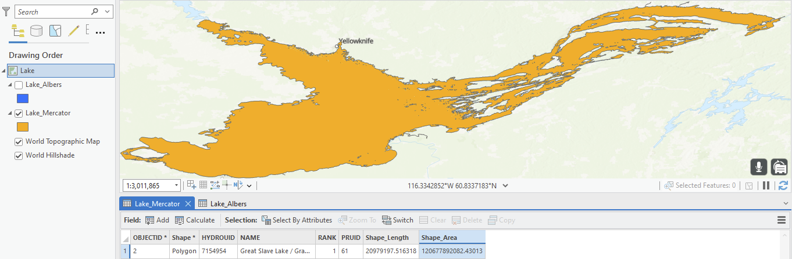

However, using a projection created specifically for Canada that is designed to preserve both shape and to some extent area as well, the Albers Equal Area, the lake size is approximately 27,065 km2. This is substantially closer to the true size of the lake, which is estimated to be 27,200 km2.

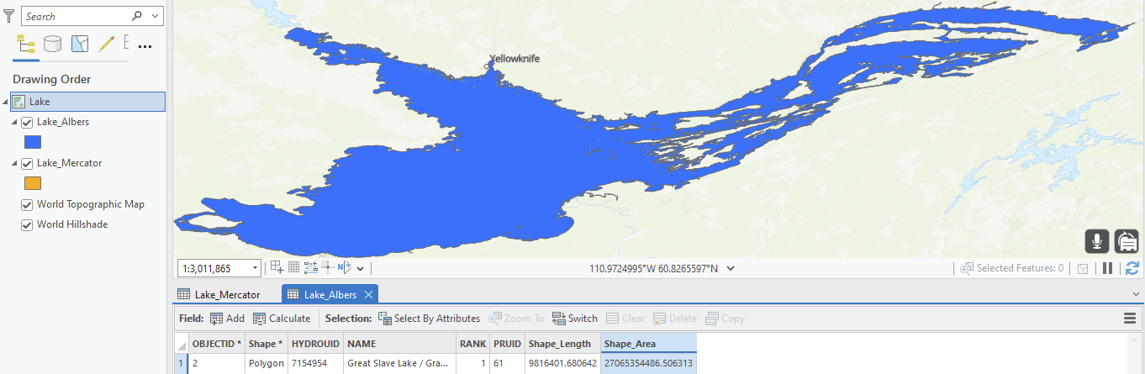

It is essential to use the correct projection when you work with geospatial data. If you are planning on conducting area-based calculations or spatial analysis with the data, it is necessary that your data is projected into a projection that preserves area. Projections such as Canada Albers Equal Area Conic would be the most appropriate for area-only project needs and, likewise, Lambert Conformal Conic is appropriate for small-scale maps of Canada.

The Project tool and Project Raster tools in ArcGIS Pro can be used to convert your data into the appropriate projection. To determine a projection of a layer, right click on it, click on properties, click source, then scroll down and open the spatial reference section. Only layers that have a projection already defined can be reprojected to another projection.

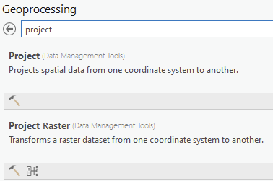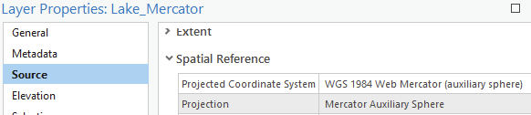

***Q2: How do I convert degrees, minutes, and seconds to decimal degrees?***

If you are given a coordinate such as 79°22’34” W, the first thing you need to do is notice that this coordinate references a location WEST of the prime meridian. Therefore, you will need to add a (-) sign to the result **after** you convert to decimal degrees. This is just convention, longitudes east of the prime meridian are considered positive, and those to the west are considered negative. To convert 79°22’34” W to decimal degrees, follow these equations:



Notice at the end, a (-) sign is added. This does not mean “negative” but rather is a way to tell someone or something that this coordinate is West, and not East, of Greenwich, England.

To reverse the process, you remove the -79 portion of the decimal degree coordinate, then you are left with decimal minutes. You multiply the decimal minutes by 60 and remove the integer portion of what is left over. Then you multiply the remaining decimal portion by 60 to get the number of seconds, like this:



Wait, why is this different from 79°22’34” W? Note that you would ideally do this on a calculator or computer, otherwise you would get a different result for the seconds due to numerical precision (the number of decimal places you retain vs. a computer), as happened here. Ignorance of numerical precision could lead to greater errors! Luckily, these calculations are easy to make in ArcGIS’s Python window. Open the python window from the ArcGIS Pro Analysis ribbon:

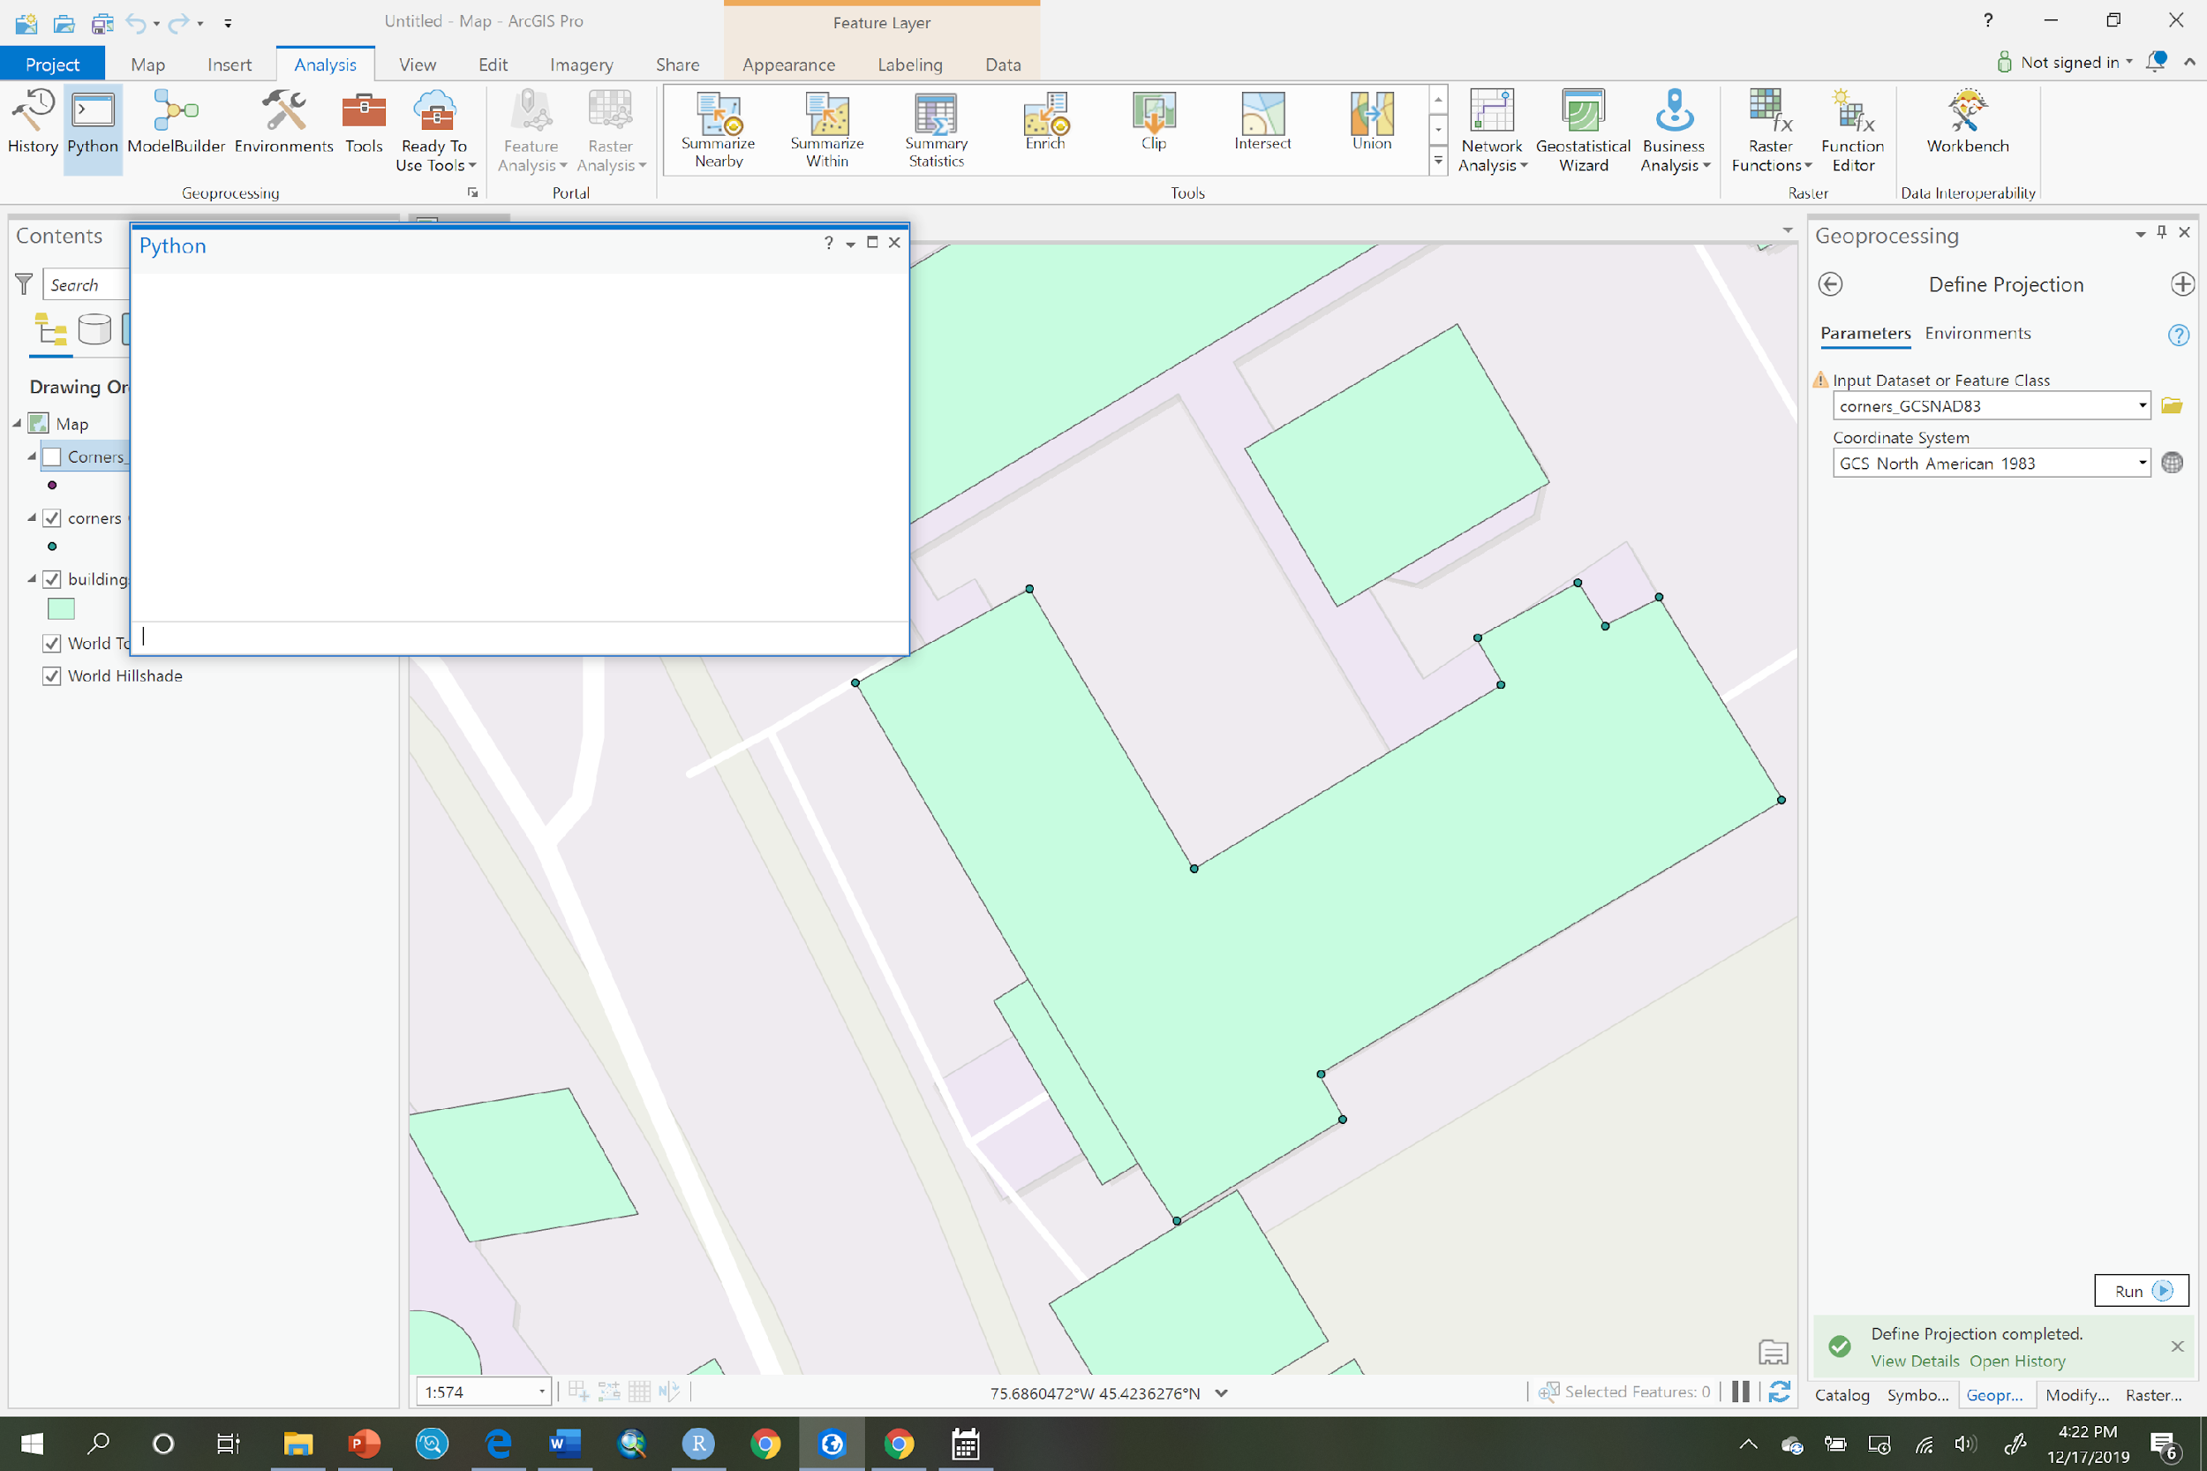

Type the following:

dd = 79 + 22.0/60.0 + 34.0/60.0**2

This statement will store the result in a variable called dd within the python window. To see what is stored, type the name dd like this, and press Enter:

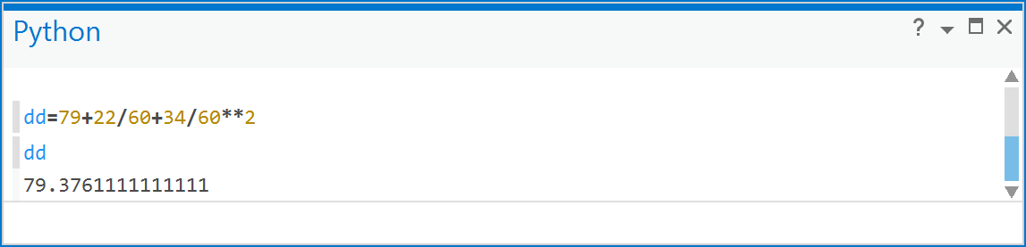

You can see there are many decimal places, in fact the 1’s repeat for a long time. So, convert dd back to degrees, minutes, and seconds. First, we remove the 79, making note of it on a piece of paper, to arrive at the decimal minutes (DM),

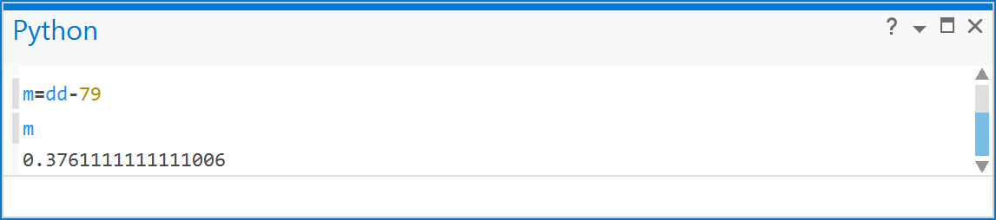

So, now in m, you have the decimal minutes portion, so we will multiply it by 60 and store the result in a variable called mins,

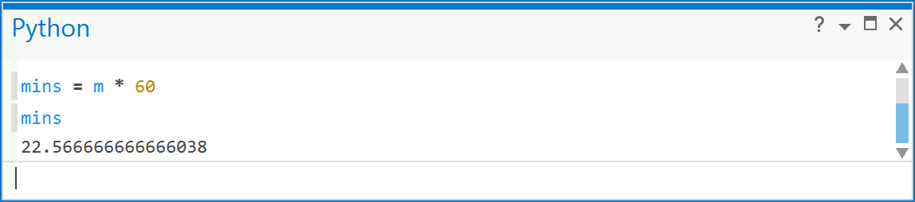

Also make a note of 22 minutes, wherever you noted 79 degrees previously. Finally, remove the 22 minutes:

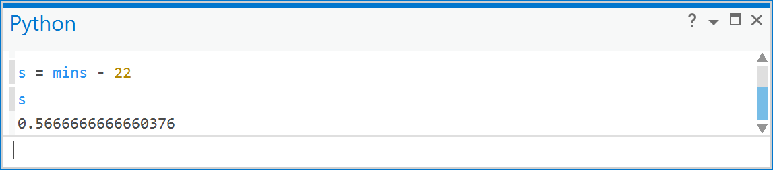

and multiply the result stored in s by 60 to arrive at the number of seconds,

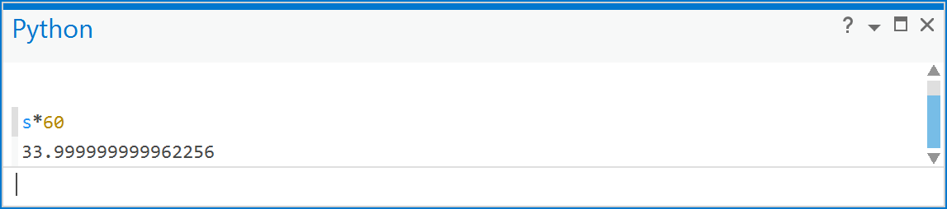

So, this can be rounded to 34”. You can see readily that, even though 79°22’34” Wis expressible as the sum of rational numbers, the computer cannot retain enough decimal places to ensure a perfect 34” result, and so the result can be irrational. This should be considered a source of uncertainty when converting from DMS to DD.

***Q3: What is the real-world distance of 1 degree of longitude at the equator?***

The distance of one degree of longitude, e.g., if you were to sail from longitude 0° to 1° W exactly along a line of latitude, based on the assumption that the Earth is a sphere, is given by:



Latitude is typically given in radians rather than degrees, which is $rad=deg×\frac{π}{180}$. So, for example, given a latitude of 0°:



So there are 111 km in 1 degree of longitude - at the equator.

***Q4: How do I calculate the real-world distance between two points using longitude and latitude?***

You can calculate the distance between two points for which you know the longitude and latitude using what is called the *Haversine formula* for great-circle distance. This formula assumes that the earth is a sphere, and the following equation provides an *approximation* to the true geodesic distance (distance on an ellipsoid):



The above equation assumes that all angular measures are in radians. So, for example, if we have the following two points:

|  |  |  |  |
| --- | --- | --- | --- |
| Point 1 | | Point 2 | |
| LAT | LONG | LAT | LONG |
| 46.62006 | -84.3039 | 46.62009 | -84.3038 |



So, the approximate distance between these two points for a spherical model of the earth, of radius 6378 km, is just over 4 m. You should always use a computer to do such calculations because the retention of many decimal places is required. Like the above example, you could do this in the python window in ArcGIS quite easily (make note of the use of parentheses!):

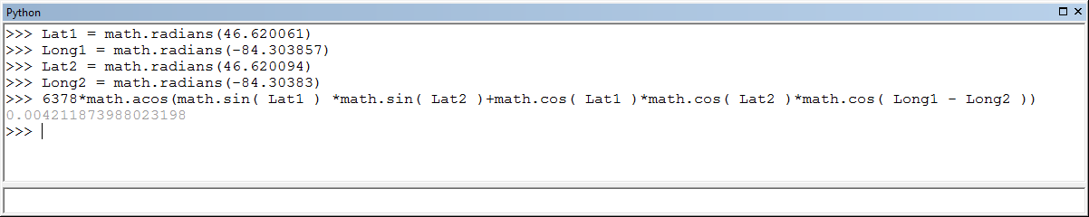

In the above example, the units are in km because the radius of the earth was in km. You can convert to meters by multiplying the result by 1000. You could also do this in Excel using the RADIANS() and ACOS(), COS() and SIN() functions in a spreadsheet formula.

***Q5: How do I calculate the location uncertainty for a digital layer?***

A paper map is produced from aerial photography using photogrammetric techniques. A photogrammetrist looks at two overlapping air photos using a stereoscope and uses a range of techniques and specialized knowledge to transfer (trace) those features onto a transparent sheet of acetate. The flying height and camera lens as well as some other aspects of the air photo determine the scale and, in turn, determines the largest map scale that the cartographer can produce from such photos. You can see how a stereoscope works with airphotos here: <https://youtu.be/mZkmXEFw7BE>. The map that the cartographer produces is then manually or digitally digitized using either human or machine algorithms to create digital geospatial data layers used in geomatics processes within a GIS.

As a function of this process, a digital geospatial data layer that originates from a paper map has a **base scale** associated with it. The **base scale** is the map scale upon which the eventual digital representation is based. These digital representations then become thematic layers such as roads, built-up areas, rivers, forested area etc. For example, a 1:50,000 map of the Ottawa region (NTS O31G5) looks like this:

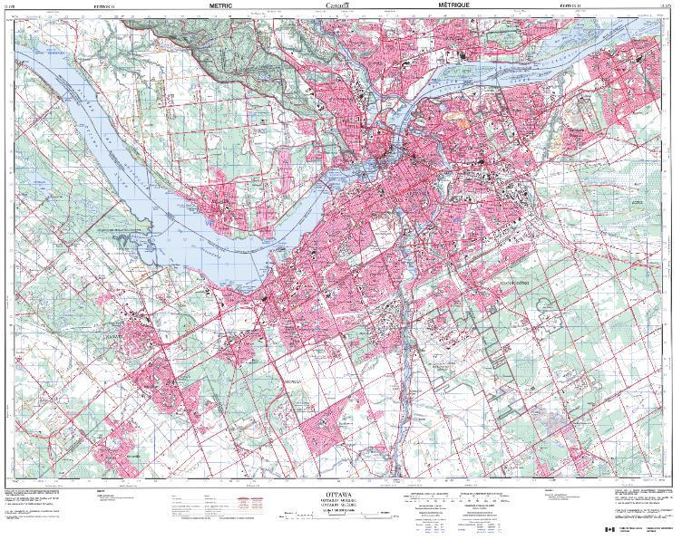

The smallest feature on a map that can be seen at a regular viewing distance on a map is 0.5 mm. So, for a map of 1:50,000 scale, that 0.5 mm line (or 0.5 mm diameter of a point) is covering a width of 0.5 mm x 50,000 = 25,000 mm, or 25 m, in the real-world.

Assuming the cartographer was unbiased in tracing objects on the air photos when making the map representation, then we can say that a position (a coordinate pair) read from a feature on that map would be at most ½ the 0.5 mm line width away from its true location. Why, because we must assume that the true location of a feature on a map is in the center of the 0.5 mm line. 0.5 x 25 m = 12.5 m, so the uncertainty of a position read from a feature on a 1:50,000 scale map would be ~12.5 m. Such positional uncertainty is important to keep in mind when you use geospatial data. If you’re using a map to plan a picnic, a 12.5 m error in where you tell them to meet is not a big deal. But if you’re landing a plane at night, 12.5 m off to the side could put you outside the runway, or if you’re building a bridge that links to the road on the other side…

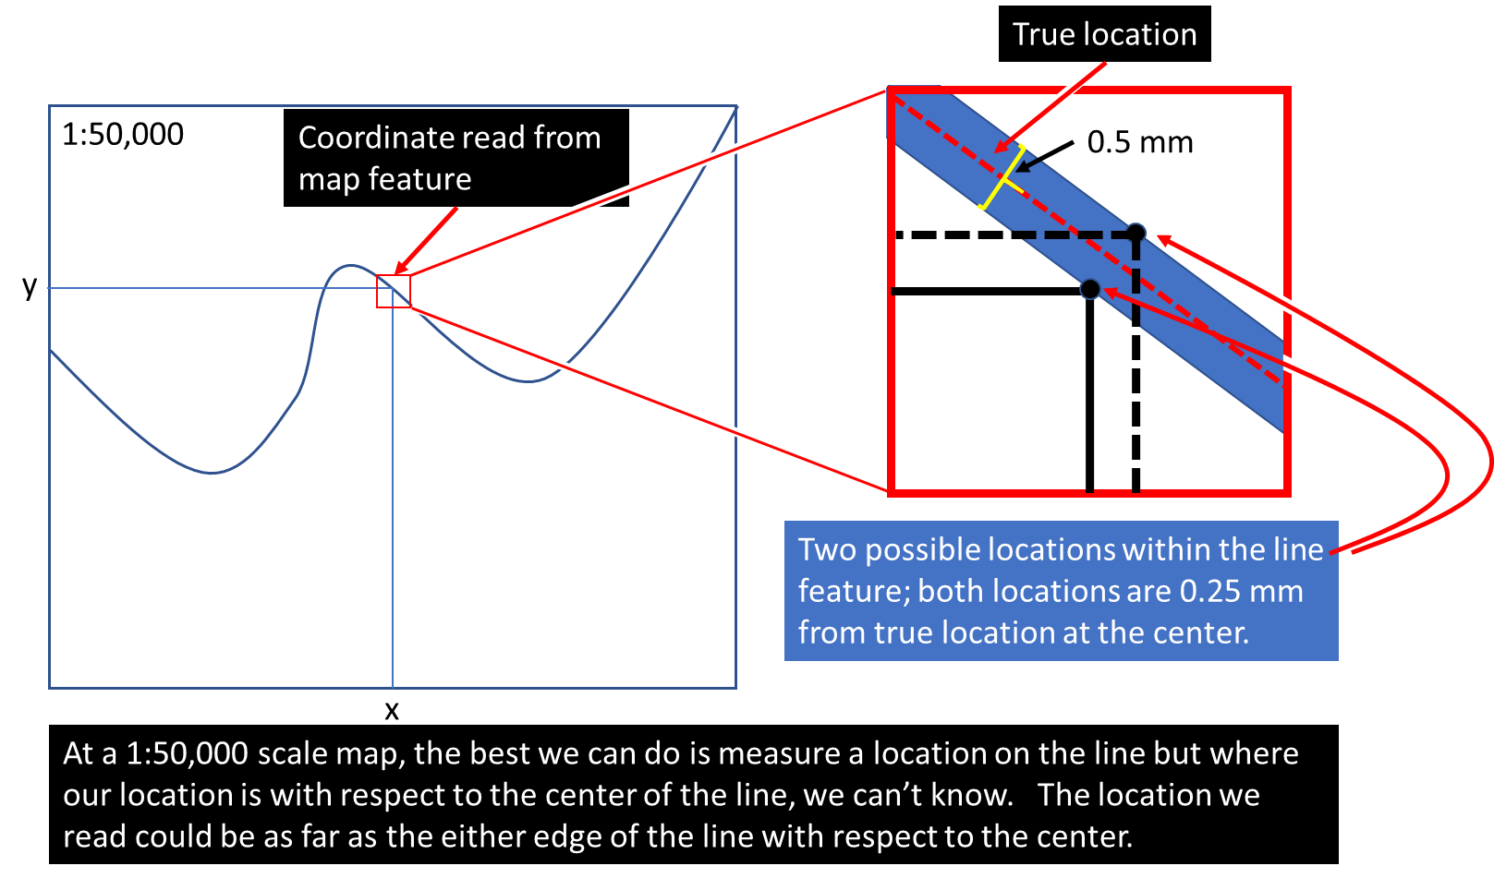

A related concept is the minimum resolvable feature, and this is based on the map scale. The minimum resolvable feature refers to the minimum separation distance between two lines so that they are distinguishable as individual entities on a map. That value is based only on the 0.5 mm value and represents, in the case of a 1:50,000 scale map, the value of 25 m.

So, to calculate the uncertainty in position of a geospatial map layer due to the **base scale only** do the following:



However, a digital geospatial layer that originates from a paper map involves additional uncertainty because whatever entity (human or AI) that created the digital representation had to extract features from the paper map by tracing them into a GIS system. That process is called **digitization** and itself adds more uncertainty. A machine or person cannot trace features on a paper map perfectly. A perfect trace would occur when the person/machine always traces the features at the exact centerline of the feature represented on the map, but that doesn’t happen very often, even when done using machine algorithms because of simple things like image distortion when a map is photographed (digitized), paper stretching or shrinking due to humidity and/or within a scanner, etc. The figure below shows an example where the location of a digital feature (black line) is located within, but not in the center of, the underlying feature (thick red line).

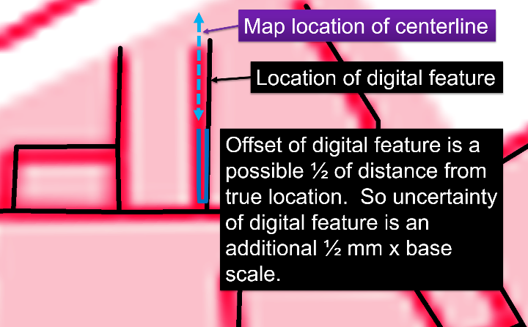

Assuming that the digital representation stays within the 0.5 mm feature width while tracing the map, then, at most, a coordinate of a location on the digital representation (black lines in Figure 7) will have an uncertainty with respect to the base-map equal to that of the base-scale of the map, specifically,



The total uncertainty is calculated using error propagation formulae that assume there are **no correlations** between the errors of the person making the original map and the errors committed by the entity that transformed it into a digital representation. The total error is therefore additive, and is given by:



This formula is derived using a Taylor’s series differential equation. You can read the document called *UncertaintyinGISProcesses.pdf* for derivation of different formulae.

Finally, if you decide to print or display a map at a smaller scale than the base scale, then you would have to add another term in the above equation. Also, keep in mind this is only an approximation and there are likely other sources of uncertainty in the map-making process that are not accounted for by scale alone.

***Q6: What is the location uncertainty for a raster representation from a digital geospatial layer?***

Every raster data layer has a spatial resolution, which refers to the size of one cell in real-world units of area. For example, a raster with 10 m spatial resolution is composed of cells that are 10 m x 10 m, or 100 m2, in the real world. Assuming the raster cell is square, which most are, then the cell’s length and width are the same. In addition, the coordinate for a raster cell is referenced to the center of the cell.

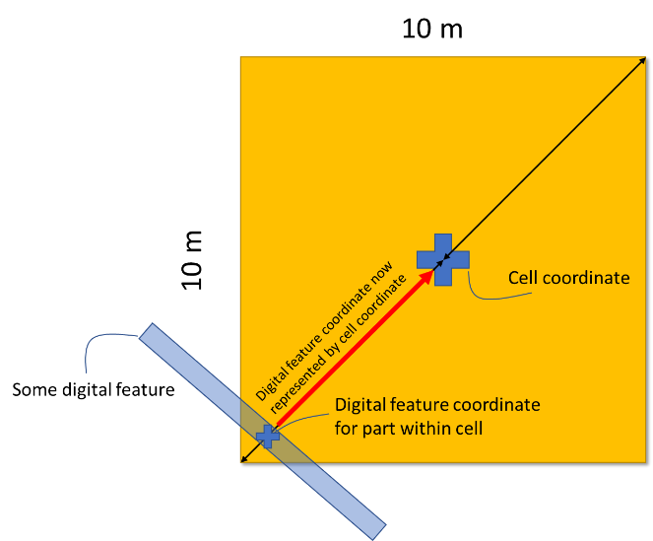

Any feature or part of a feature that has been encoded (transformed from a vector representation to a raster) to a raster could have been at most ½ the cell diagonal away from the cell center during encoding, while remaining within the cell. In such a case, the cell would be used to represent the feature or part thereof. As such, the general positional uncertainty involving the coordinate location of a feature, or part thereof, due to representation by a raster with square cells, where each cell is, for example, 100 m2, can be given as:



The uncertainty of position given by the above equation would be added to any other uncertainties if your raster was created from a vector digital geospatial layer. So, if you had a raster layer of roads with 25 m spatial resolution, and these originated from a vector layer of roads, that, in turn, was **digitized** from a paper map at a scale of 1:50,000, then the total positional error would be given by:



As such we include the raster positional error within the total error. Therefore, by definition, objects or entities in raster data have greater location uncertainty than their corresponding vector representation – if indeed the raster has been created original from vector data. Note that if you were to take a raster and convert it to vector, accuracy is not increased since the raster error of position is still present.

***Q7: If ArcGIS Pro does not recognize the coordinate system for a layer, how do I tell ArcGIS what the coordinate system is for the layer?***

When a geospatial layer does not contain coordinate system information and it is added to ArcGIS Pro, you may see a warning, and often you just won’t see your spatial data layer where you expect to find it. The figure below is a typical situation, where the data ended up near 0° latitude and 0° longitude. If you add data to your project and can’t find them, this is often a good place to look for them!

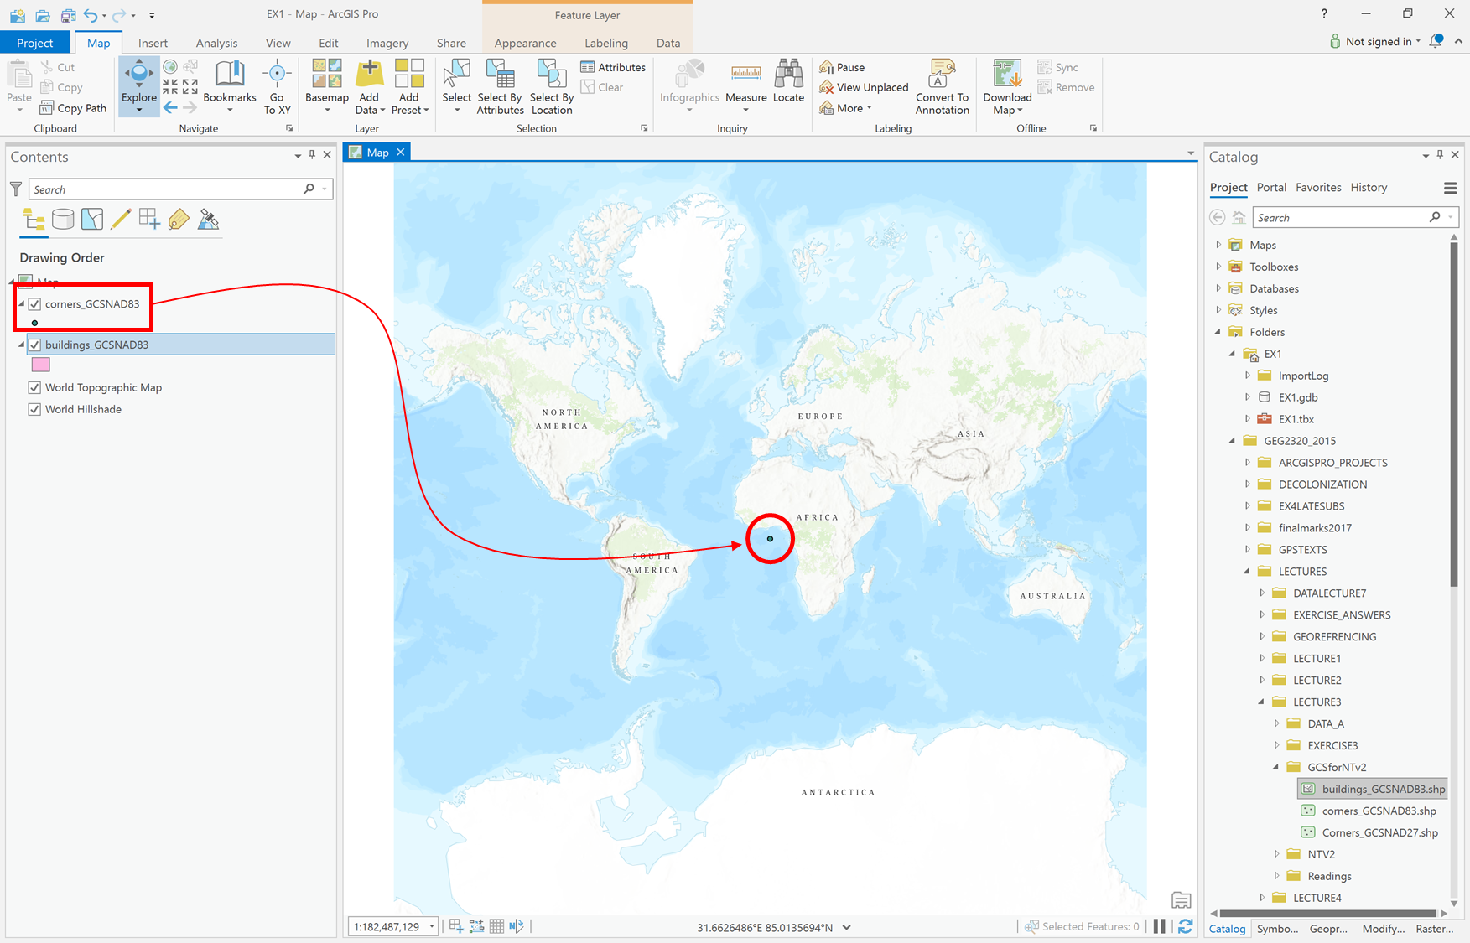

ArcGIS Pro will still display the layer, but it won’t line up with other layers that have known coordinate systems.

In the GCSforNTV2 folder you have the following layers, with the following coordinate systems:

|  |  |
| --- | --- |
| *Layer* | *Coordinate System* |
| corners_GCSNAD83 | North American Datum of 1983 |
| corners_GCSNAD27 | North American Datum of 1927 |
| buildings_GCSNAD83 | North American Datum of 1983 |

1. Add the corners_GCSNAD83 layer to ArcGIS Pro in a new project.
2. Click on the “Full Extent” button in the Map tab and you will see a dot in the center of the map near 0,0 in the cartesian coordinates of the default ‘WGS 1984 Web Mercator Auxiliary Sphere’ coordinate system of ArcGIS Pro, just like the above figure. The small dot in the middle of the map contains points that represent the corners of the Simard Hall Building, in Ottawa! In order to see those points in the correct location we need to define the layer’s coordinate system and any geographic transformations required to bring the layer’s coordinates to the coordinates of the Map so that things align correctly. To do so follow these instructions.
3. Go to Project->Options:

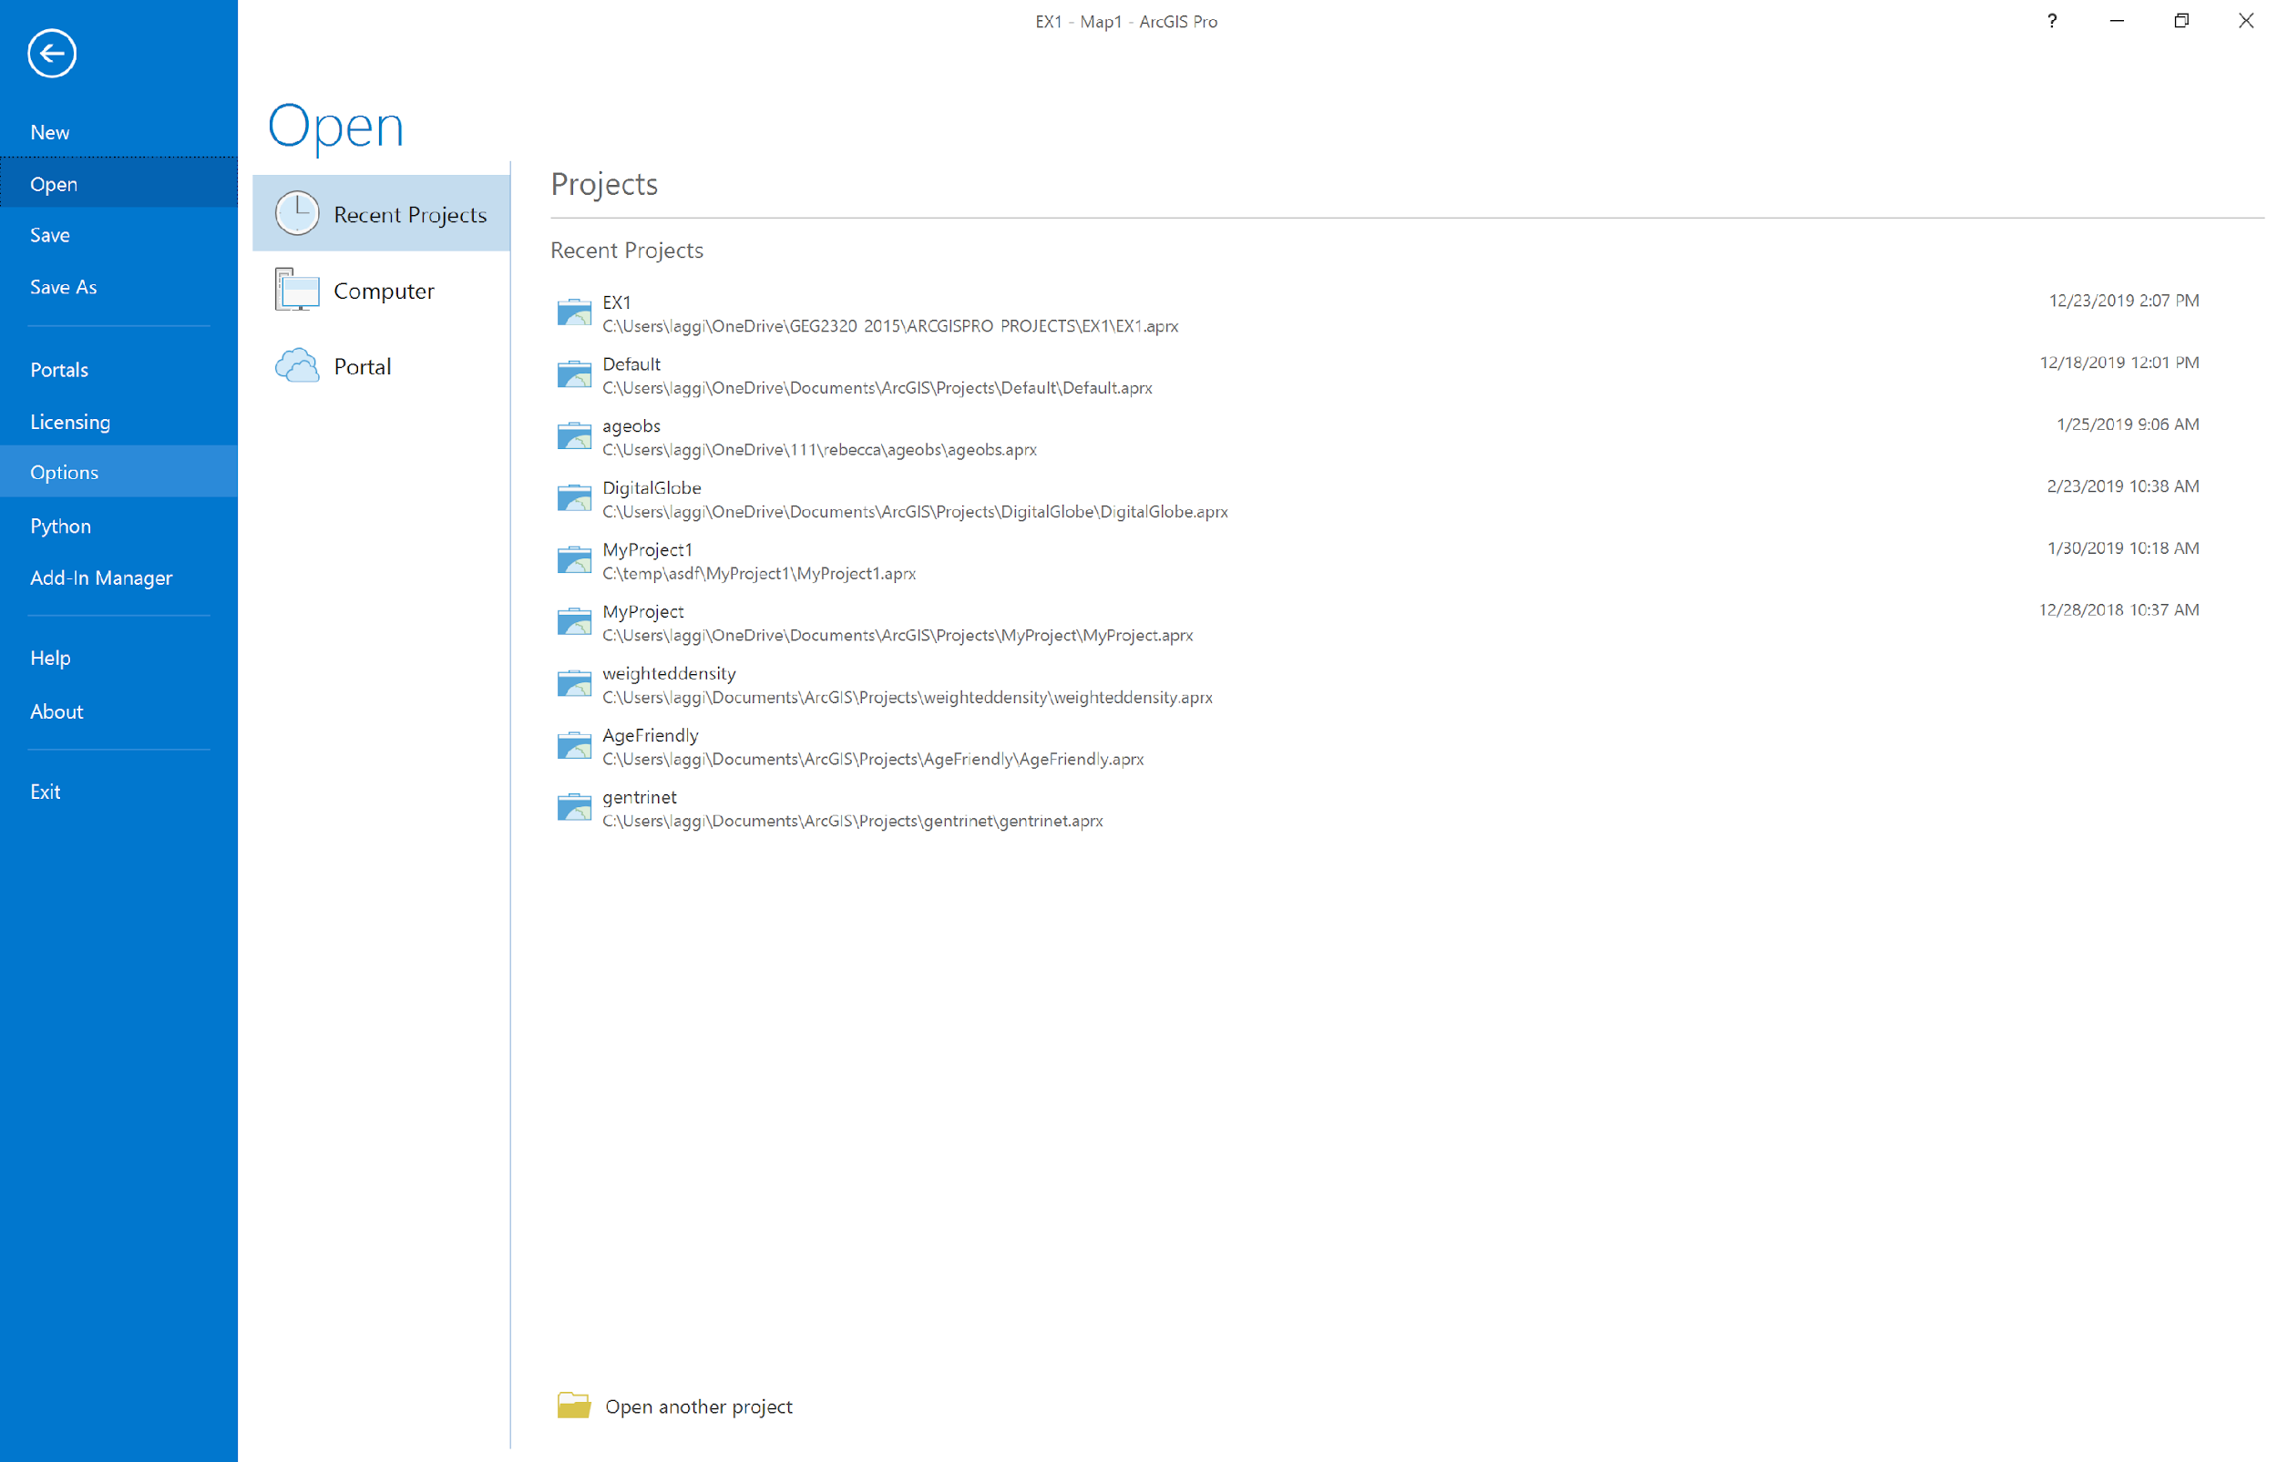

1. In the Options dialog, choose the Map and Scene item, scroll down, and put a check-mark in ‘Warn if transformation between geographic coordinate systems is required to align data sources correctly’.

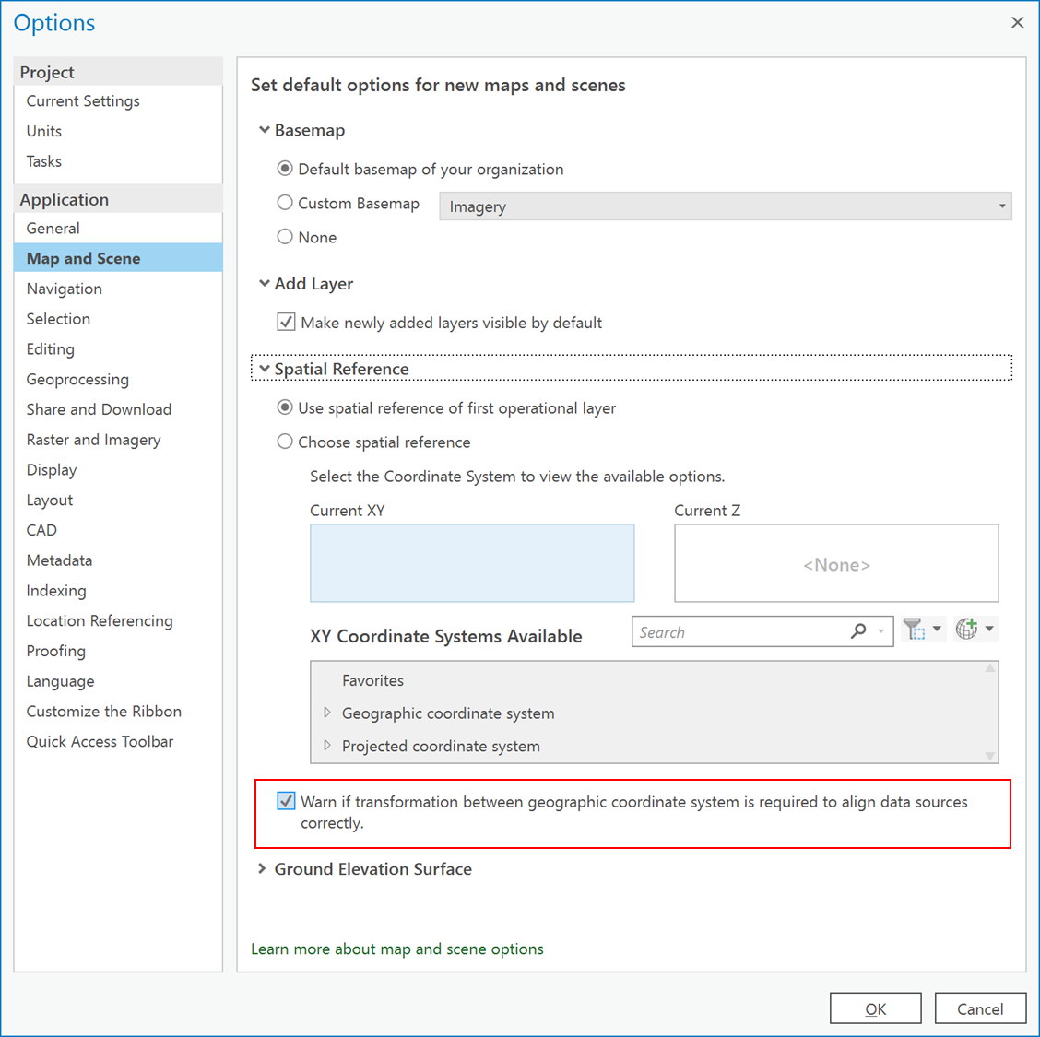

1. Go back to your Map.
2. Go to the Geoprocessing pane under Toolboxes.
3. To specify the coordinate system for the layers in ArcGIS Pro, you use the Define Projection tool under Data Management -> Projections and Transformations:

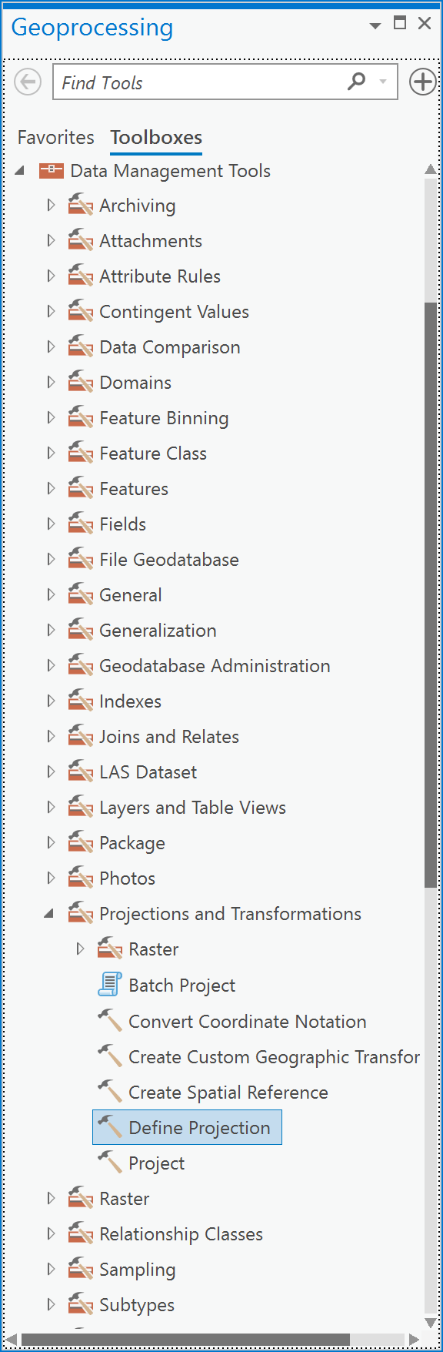

1. In the Define Projection tool, choose the layer corners_GCSNAD83 as the “Input Dataset or Feature Class”:

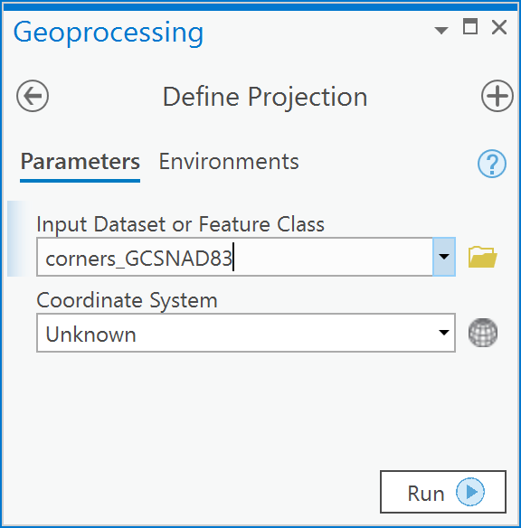

1. To the right of the “Coordinate System” input box, click on the button that looks like a globe.
2. Now, navigate to the folder Geographic Coordinate Systems -> North America -> Canada and choose “NAD 1983” and click OK.

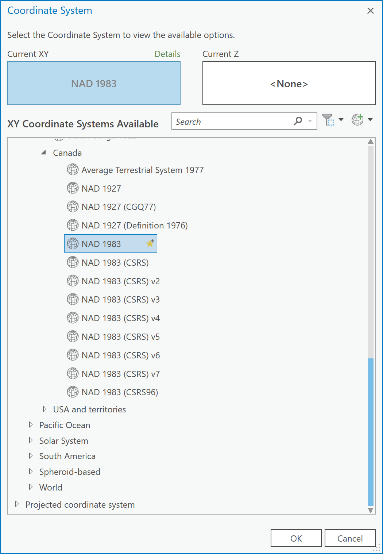

1. Your dialog will now look like this, if so, click Run:

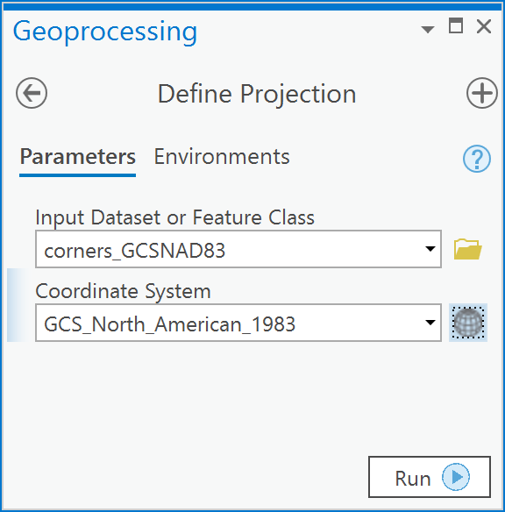

1. Once the operation is complete, you will now see the following:

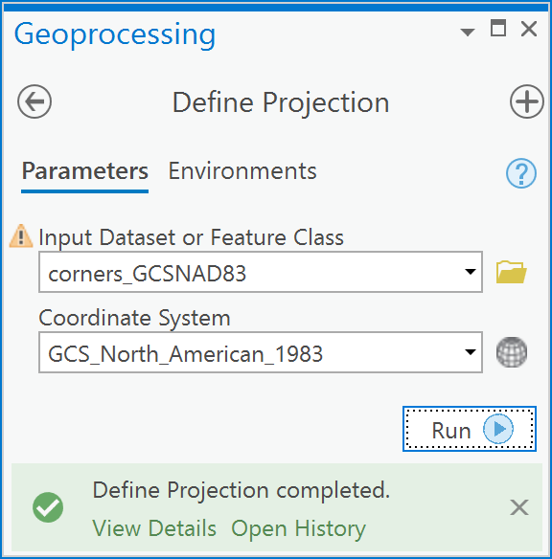

1. This means that your layer has a coordinate system defined as NAD83. Defining the projection simply tells ArcGIS what the geographic coordinate system (GCS) is for the layer. The observant student will realize that without the information in Table 1, there would be no way to know for sure what the native GCS was and, therefore, there would be no way to confidently use the Define Projection tool.
2. Now, repeat this procedure for the other two layers listed in the table, noting that corners_GCSNAD27 is in the North American Datum of 1927.

***Q8: How do I convert between NAD27 and NAD83 in Canada?***

If you add a layer to ArcGIS Pro that contains a geographic coordinate system that is different from the one defined for the Map, then you will see this warning:

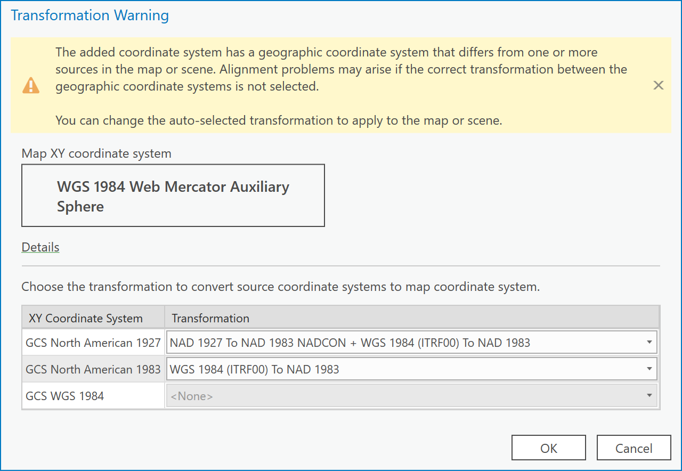

This warning means that you are trying to display two different geographic coordinate systems in the same space. ArcGIS Pro will allow you to do this if you click the ‘Cancel’ button. However, doing so means that the locations of common objects or entities won’t line up between the layer you are adding and other layers already in your data frame. For example, in the figure below, the building corners of Simard Hall are shown in black + signs with the NAD83 coordinate system, and in red dots with the NAD27 coordinate system. The two are offset because the data shown in red dots have not been transformed correctly to the NAD83 coordinate system.

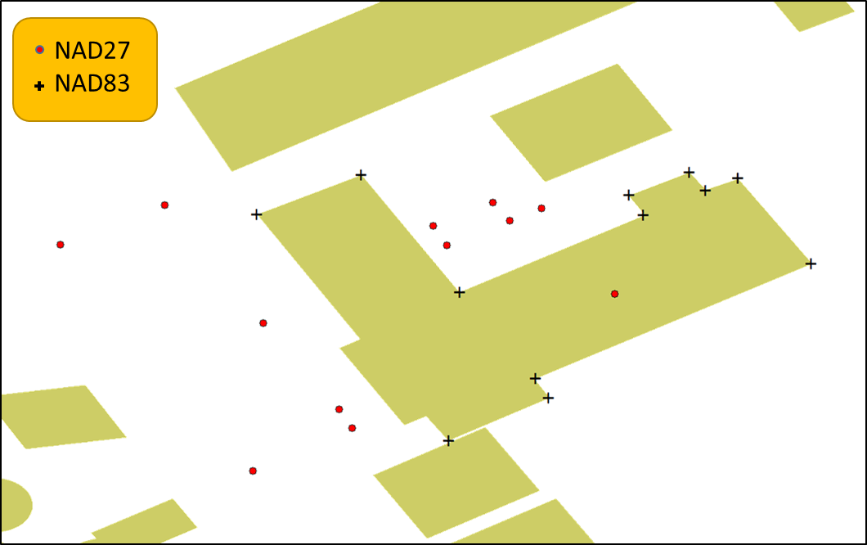

If, however, you specify the correct geographic transformation for the layers, then the data will line-up correctly, as shown below.

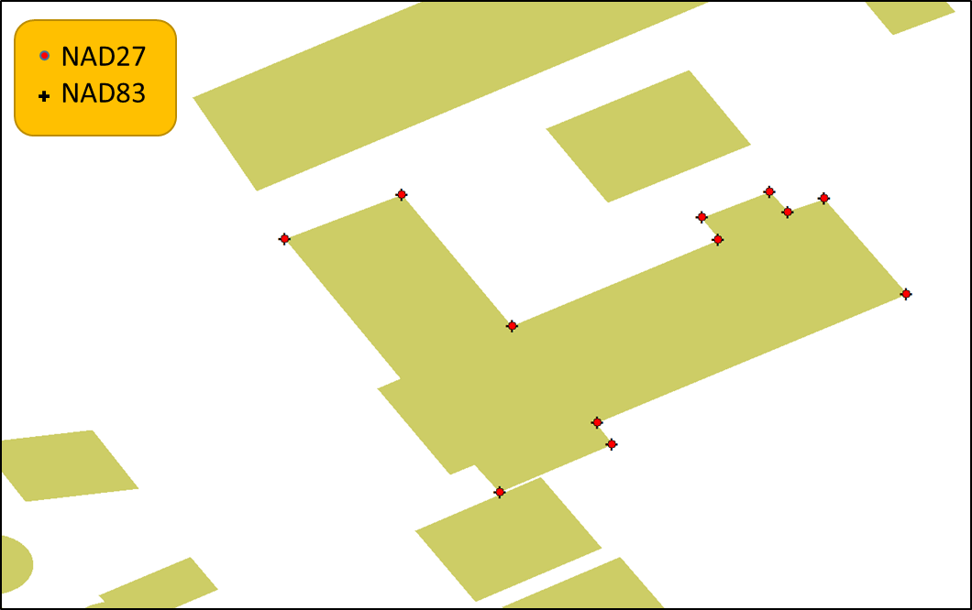

To see these effects in action,

1. Click on the Insert tab followed by the **New Map** button to create a new Map.
2. Now, from the GCSforNTv2 folder, add the layer called buildings_GCSNAD83. You will see the warning dialog, just click OK. You get this warning because the default Longitude/Latitude system called a Geographic Coordinate System (GCS) for the basemap in ArcGIS Pro is WGS 1984 (using the WGS 84 ellipsoid for horizontal coordinates), whereas the layer you added is in the North American Datum of 1983 (using the GRS 1980 ellipsoid for horizontal coordinates). These two use different ellipsoidal models for their 3D long/lat coordinate system. Click OK.

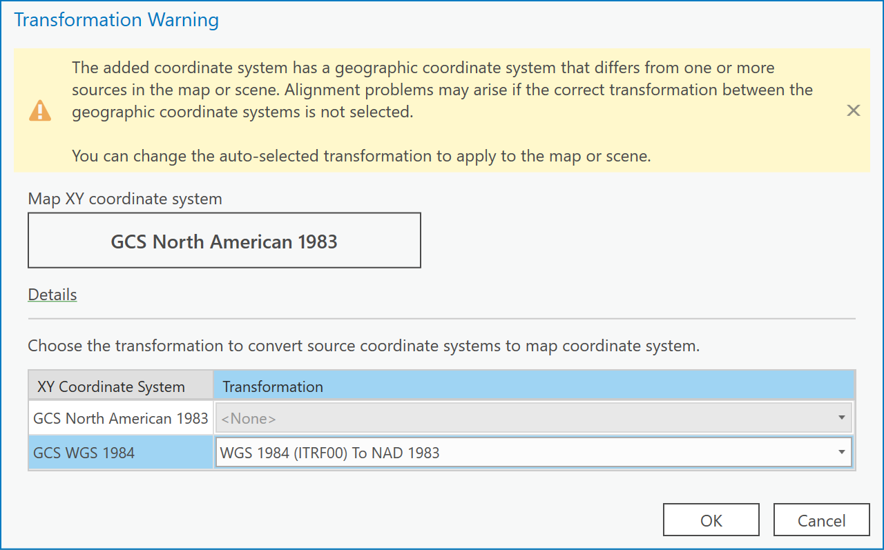

1. Now add the corners_GCSNAD83. There will be no warning dialog this time.
2. Zoom into the extent of the layer corners_GCSNAD83. You will see that the point layer called corners_GCSNAD83 lines up with the corners of the Simard Hall building:

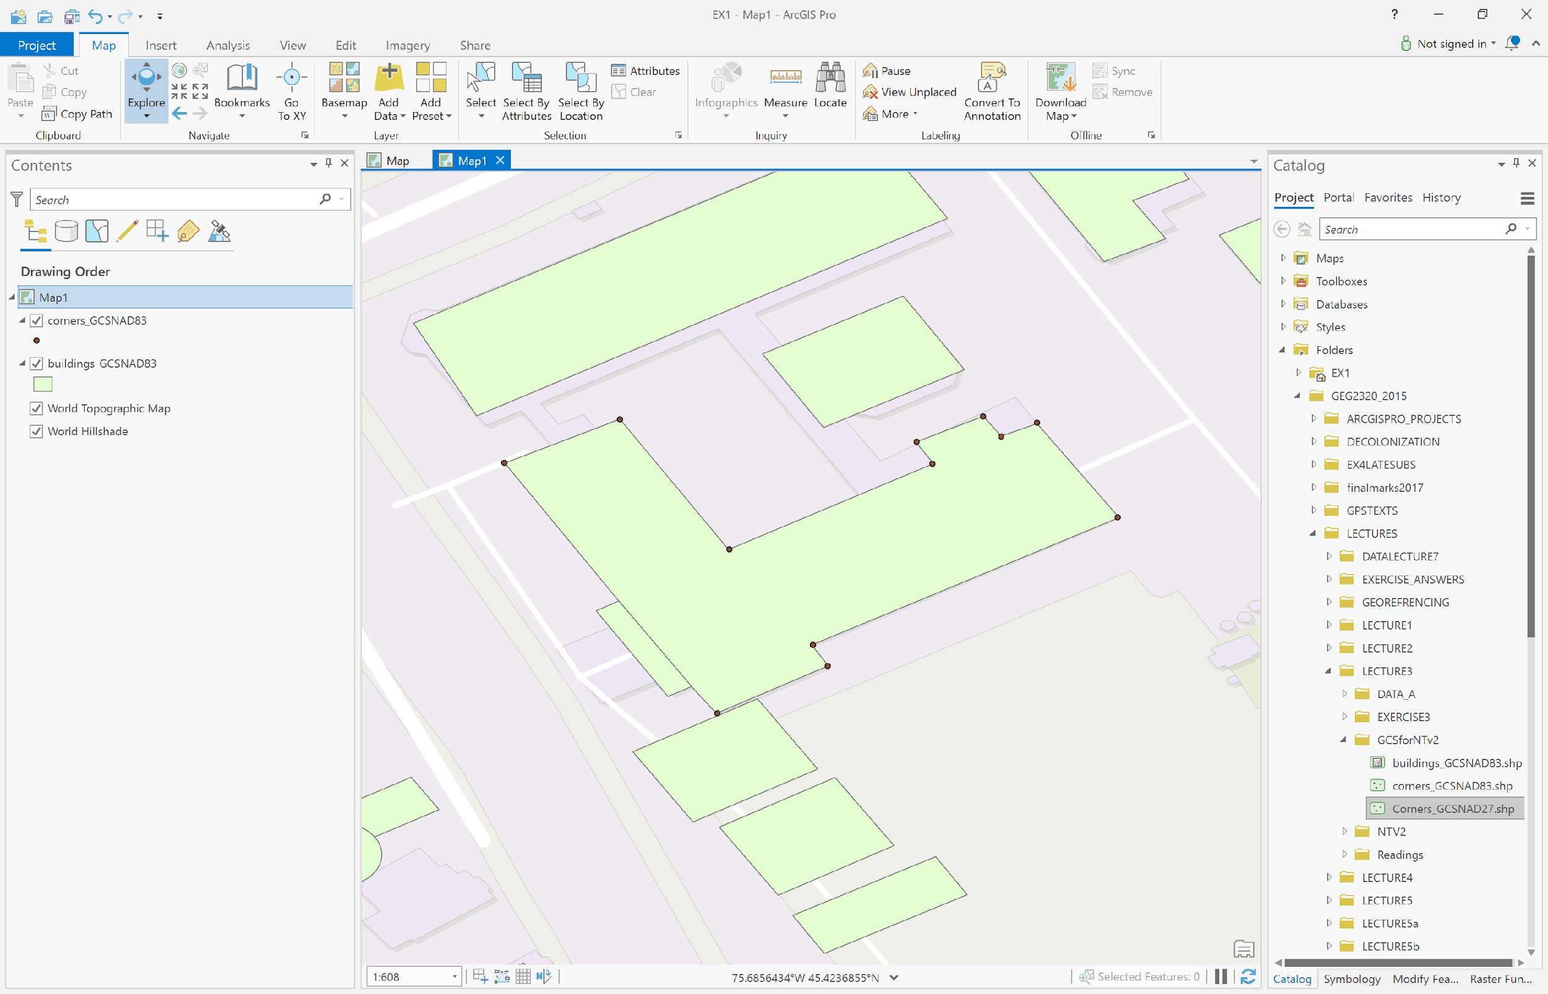

1. Then add the layer Corners_GCSNAD27. You will see a warning dialog that specifies that the GCS of the added layer, namely Corners_GCSNAD27, is different from the GCS of the map. That is because the Corners_GCSNAD27 has a geographic coordinate system of the North American Datum of 1927 (NAD 27), whereas the Map coordinate system was defined by the coordinate system of the first layer added, namely, the Buildings_GCSNAD83 which is in the North American Datum of 1983 (NAD 83). So, this dialog is asking you how to transform between NAD 27 and NAD 83:

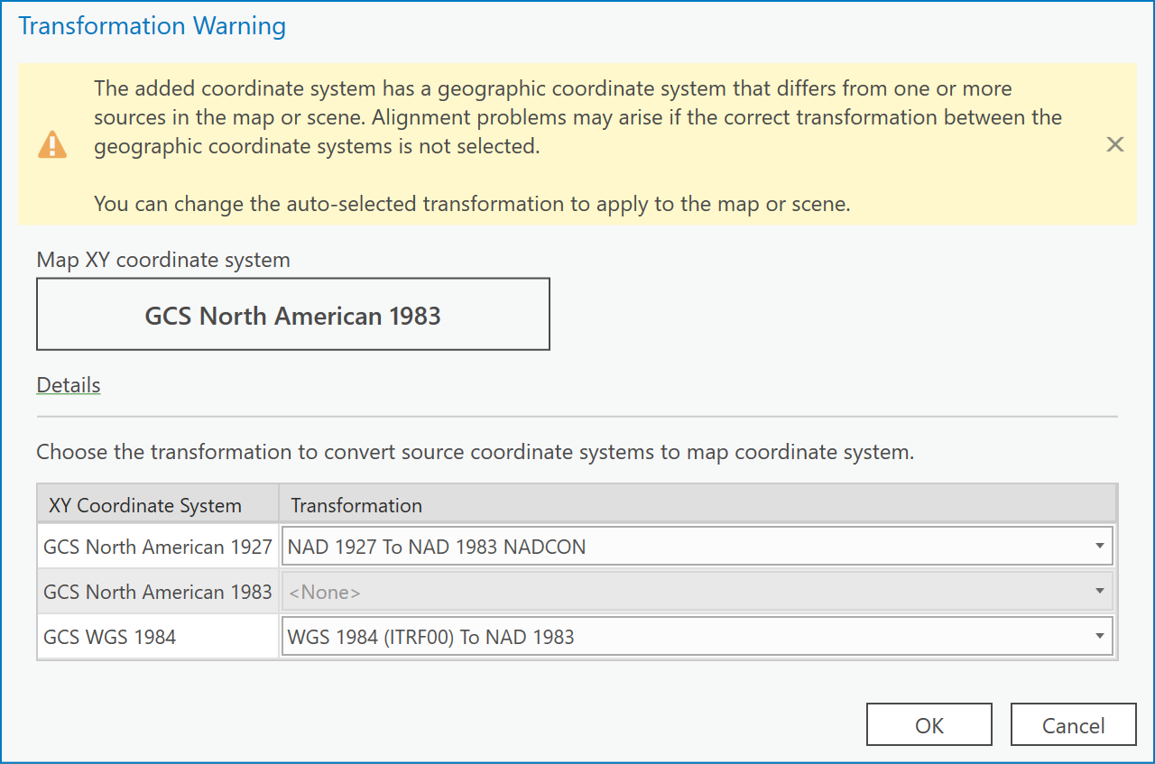

1. Click on the dropdown beside ‘GCS North American 1927’:

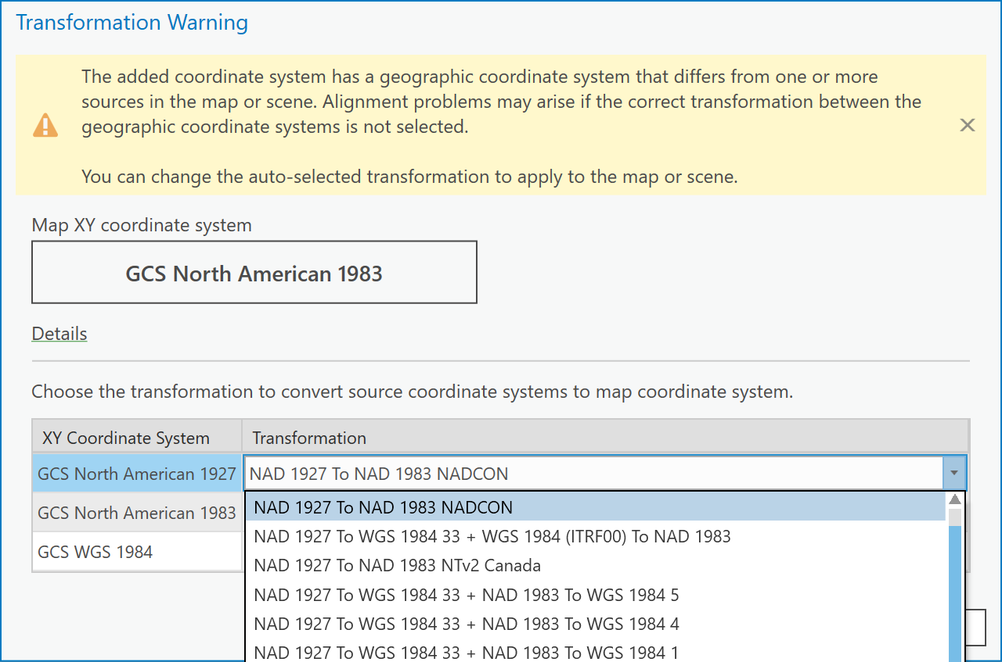

1. Choose the ‘NAD 1927 to NAD 1983 NTv2 Canada’ transformation.

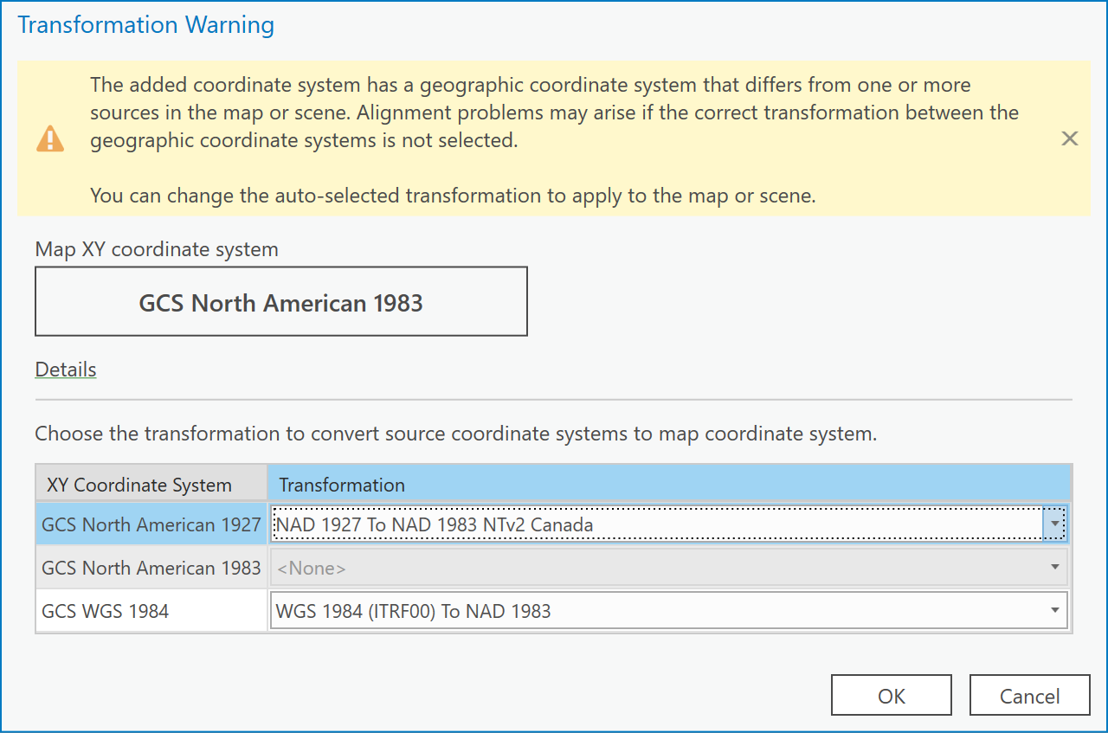

1. You will now see that all data align:

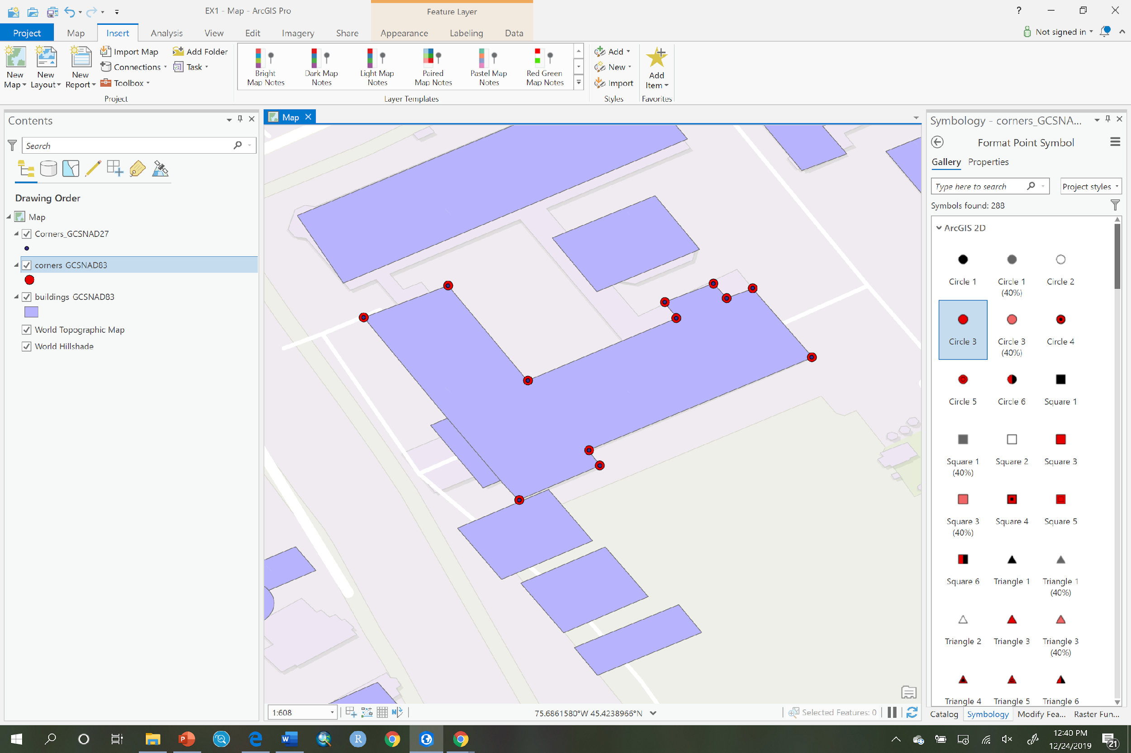

Note as well, that this process only gives a display transformation or on-the-fly transformation; the underlying data within the digital geospatial layers does not change, ArcGIS Pro has simply computed new coordinates so that all features within Corners_GCSNAD27 are displayed in coordinates of NAD83. The features stored within Corners_GCSNAD27 are still stored as NAD27, that does not change using this technique.

***Q9: How do I specify the NAD27 and NAD83 conversion after I’ve added the data already to ArcGIS Pro?***

You can specify any transformation for layers within a map in ArcGIS Pro by opening the Map properties dialog and clicking the “Transformations…” item.

1. Repeat steps 1 to 4 of example Q7.
2. Now you will see the following dialog, click “OK”



1. Your map will look like the following. When you clicked OK, you automatically chose to convert the NAD27 GCS to NAD83 by using the NADCON transformation. That transformation is only good for the lower 48 US states. NADCON is not defined for Canada. While NADCON is better than nothing, you can see that the ‘Corners_GCSNAD27’ layer does not align with the other two layers. So we need to specify the correct transformation for Canada, which is the NTV2 transform. This is easy to correct in the next step.

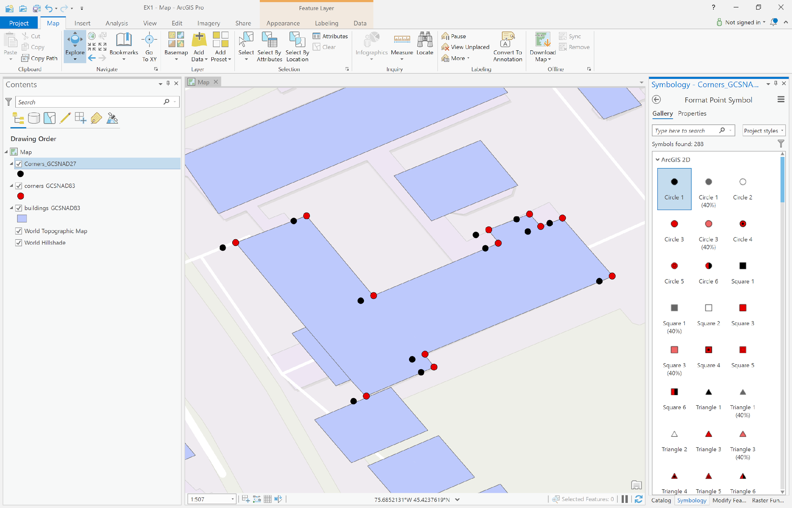

1. Right click on the Map and choose Properties

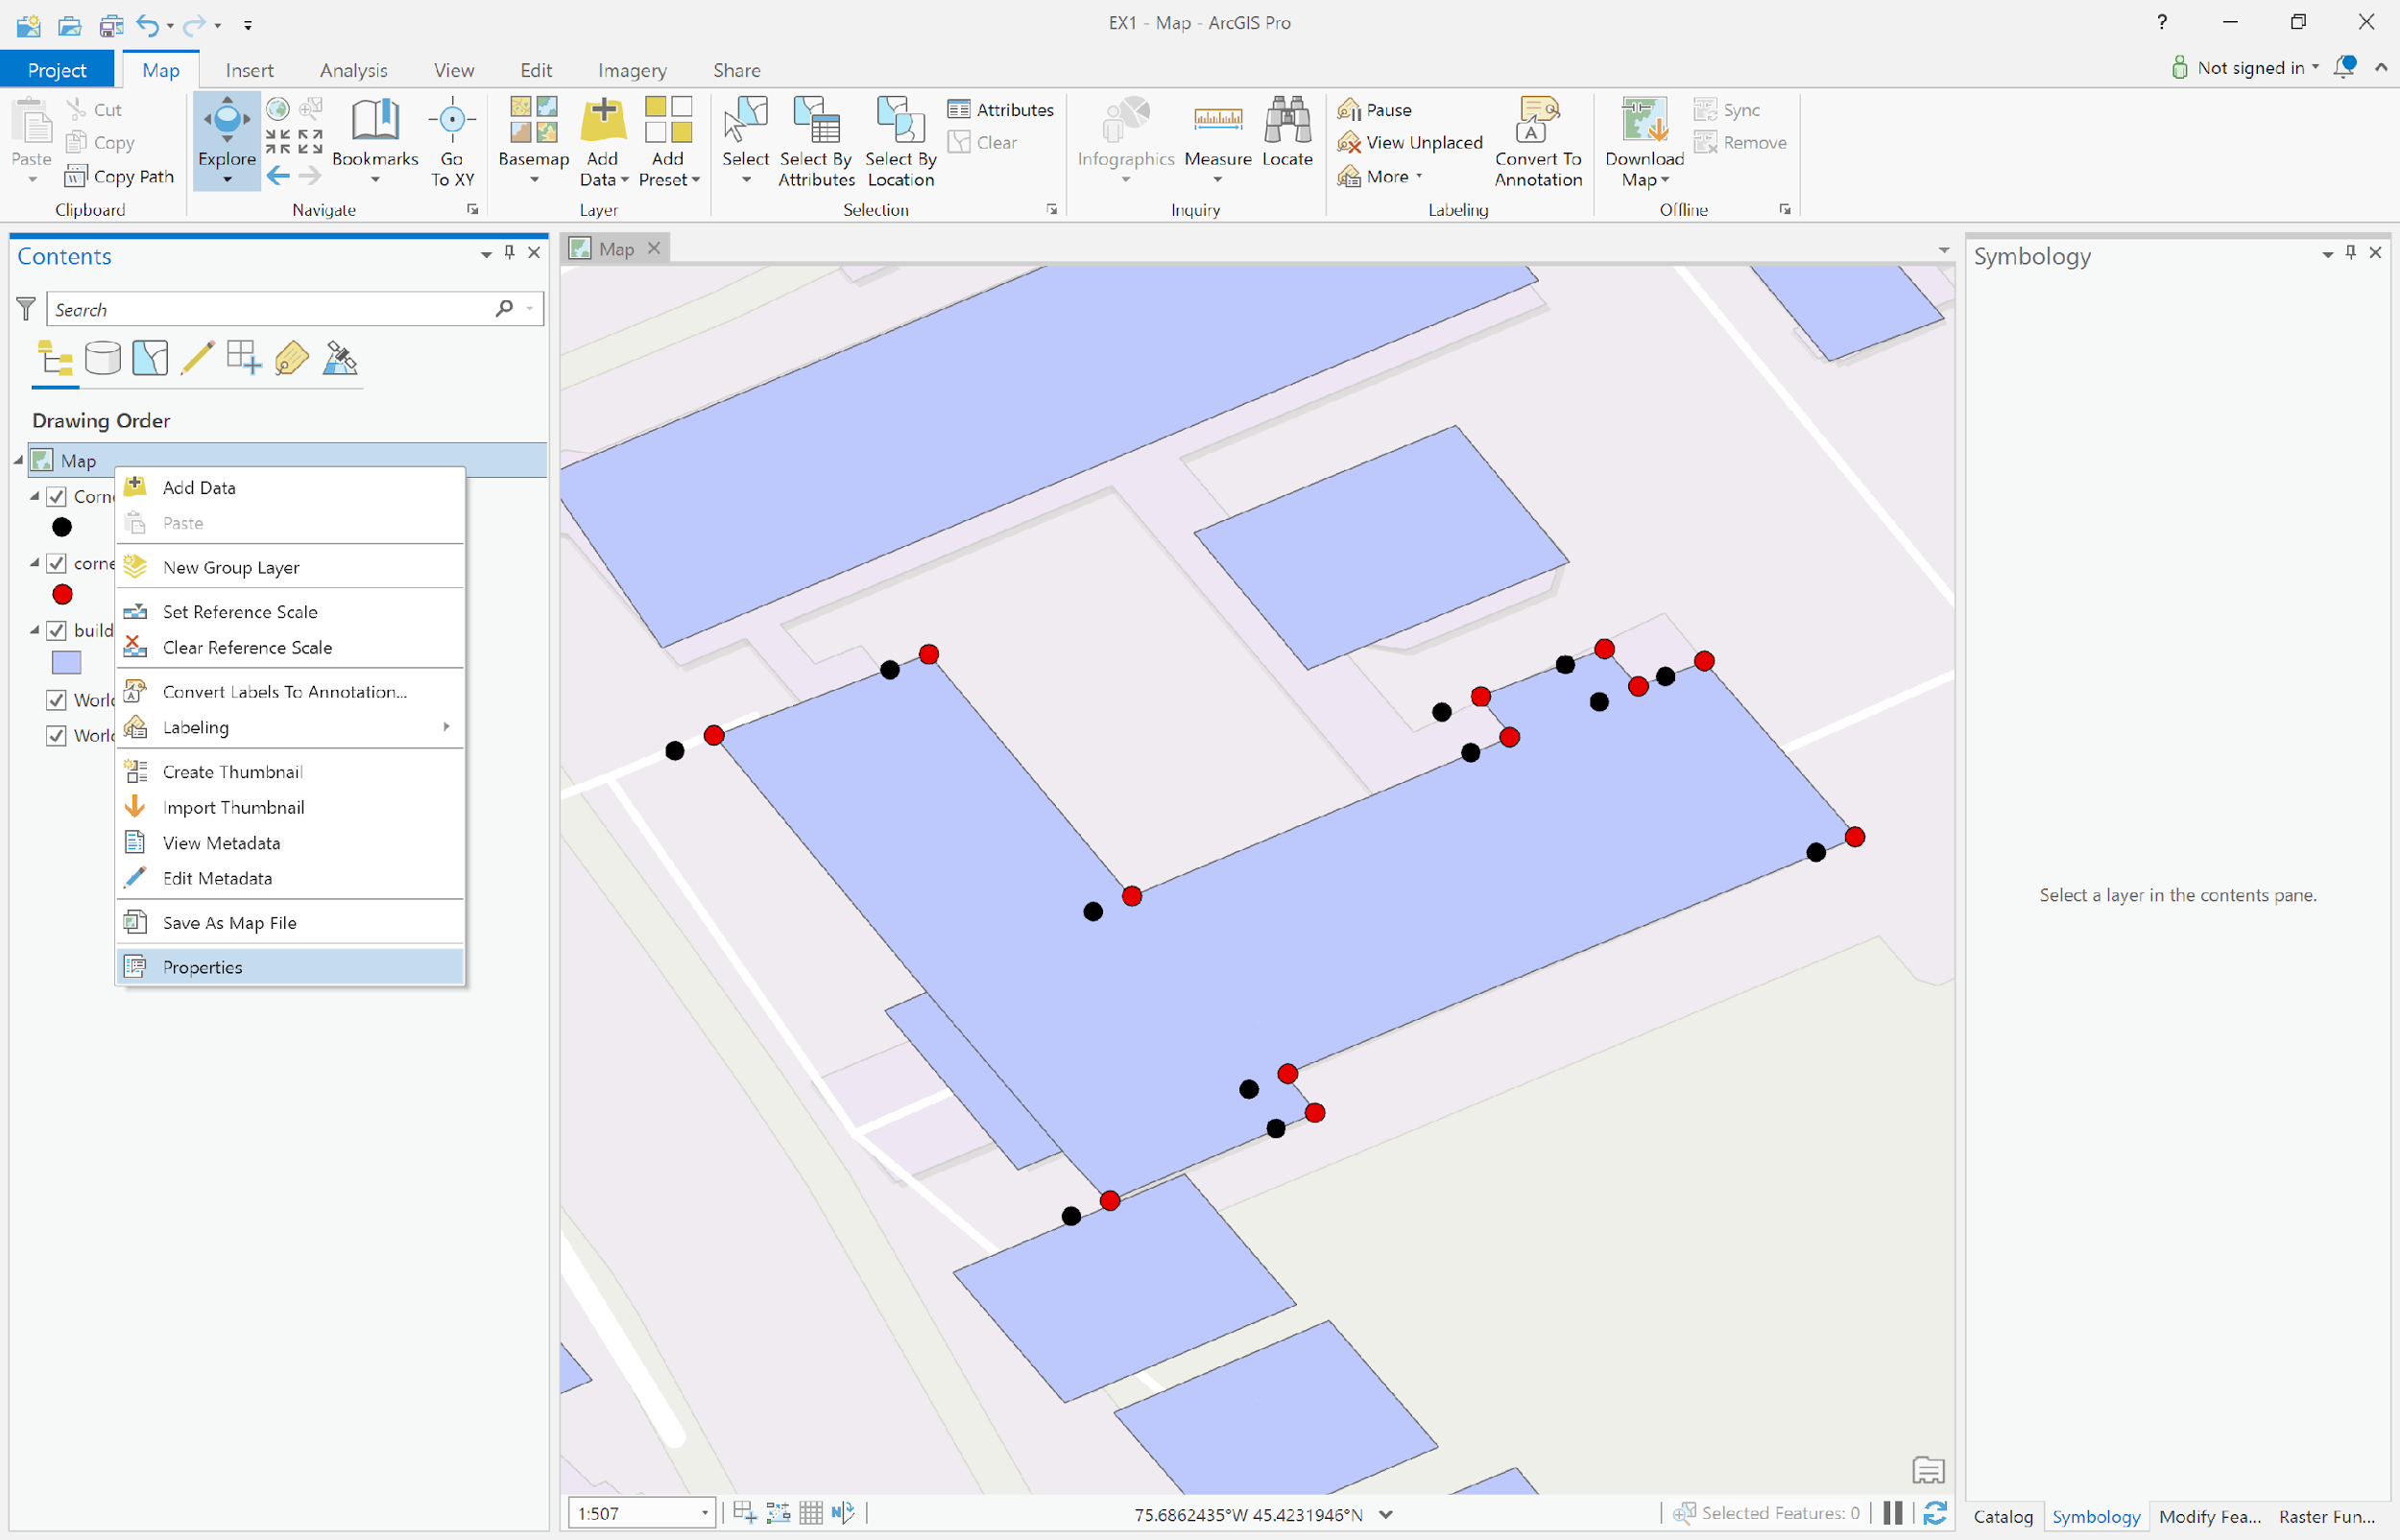

1. In the Map Properties dialog, choose the *Transformation* item:

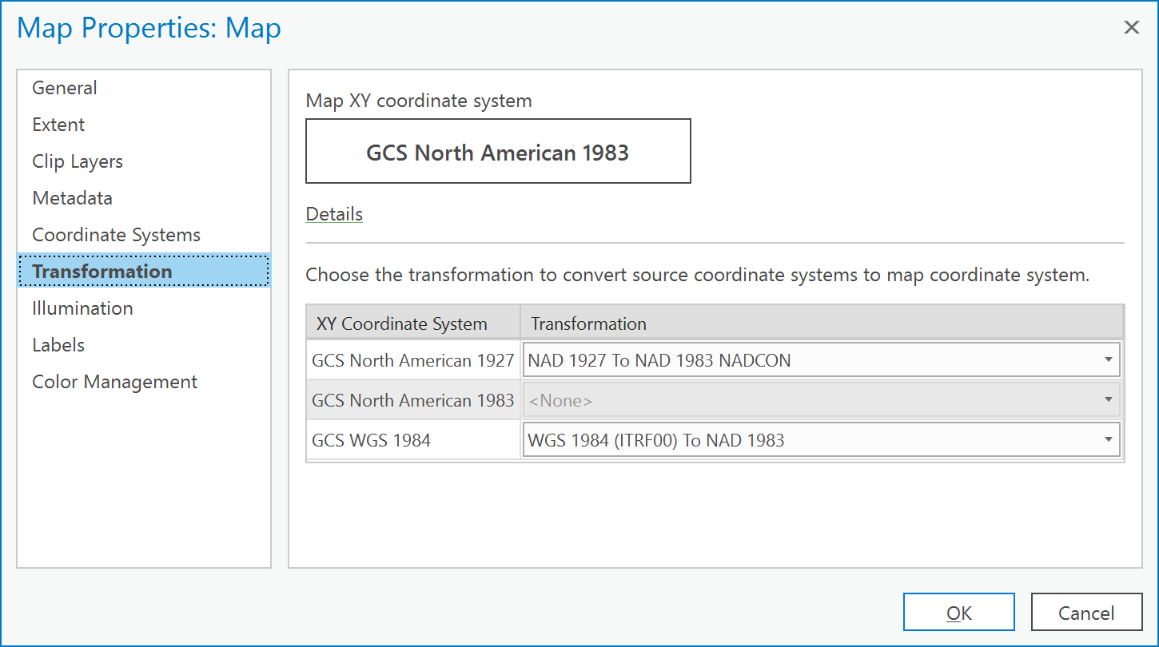

1. Click on the drop-down menu beside ‘GCS North American 1927’ and choose the ‘NAD 1927 to NAD 1983 NTv2 Canada’ transformation and then click OK:

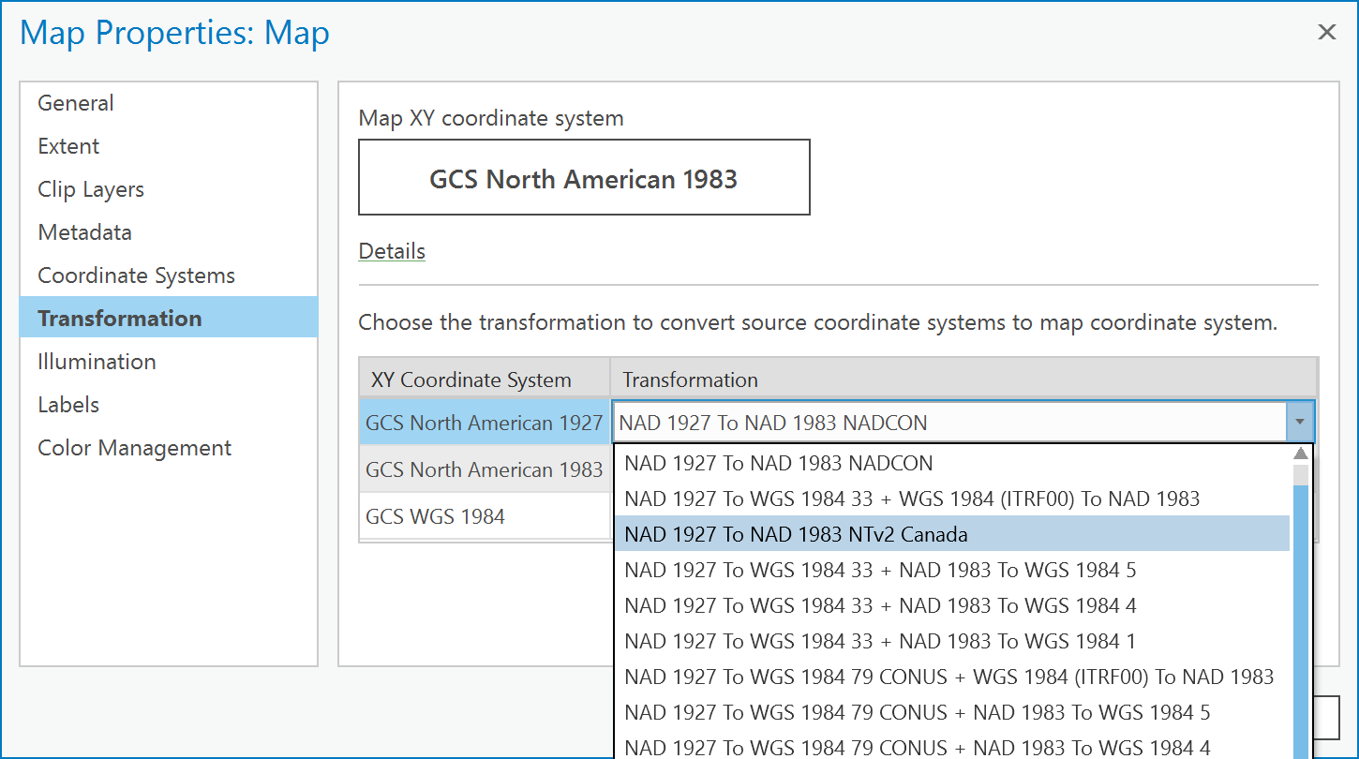

1. Now everything aligns:

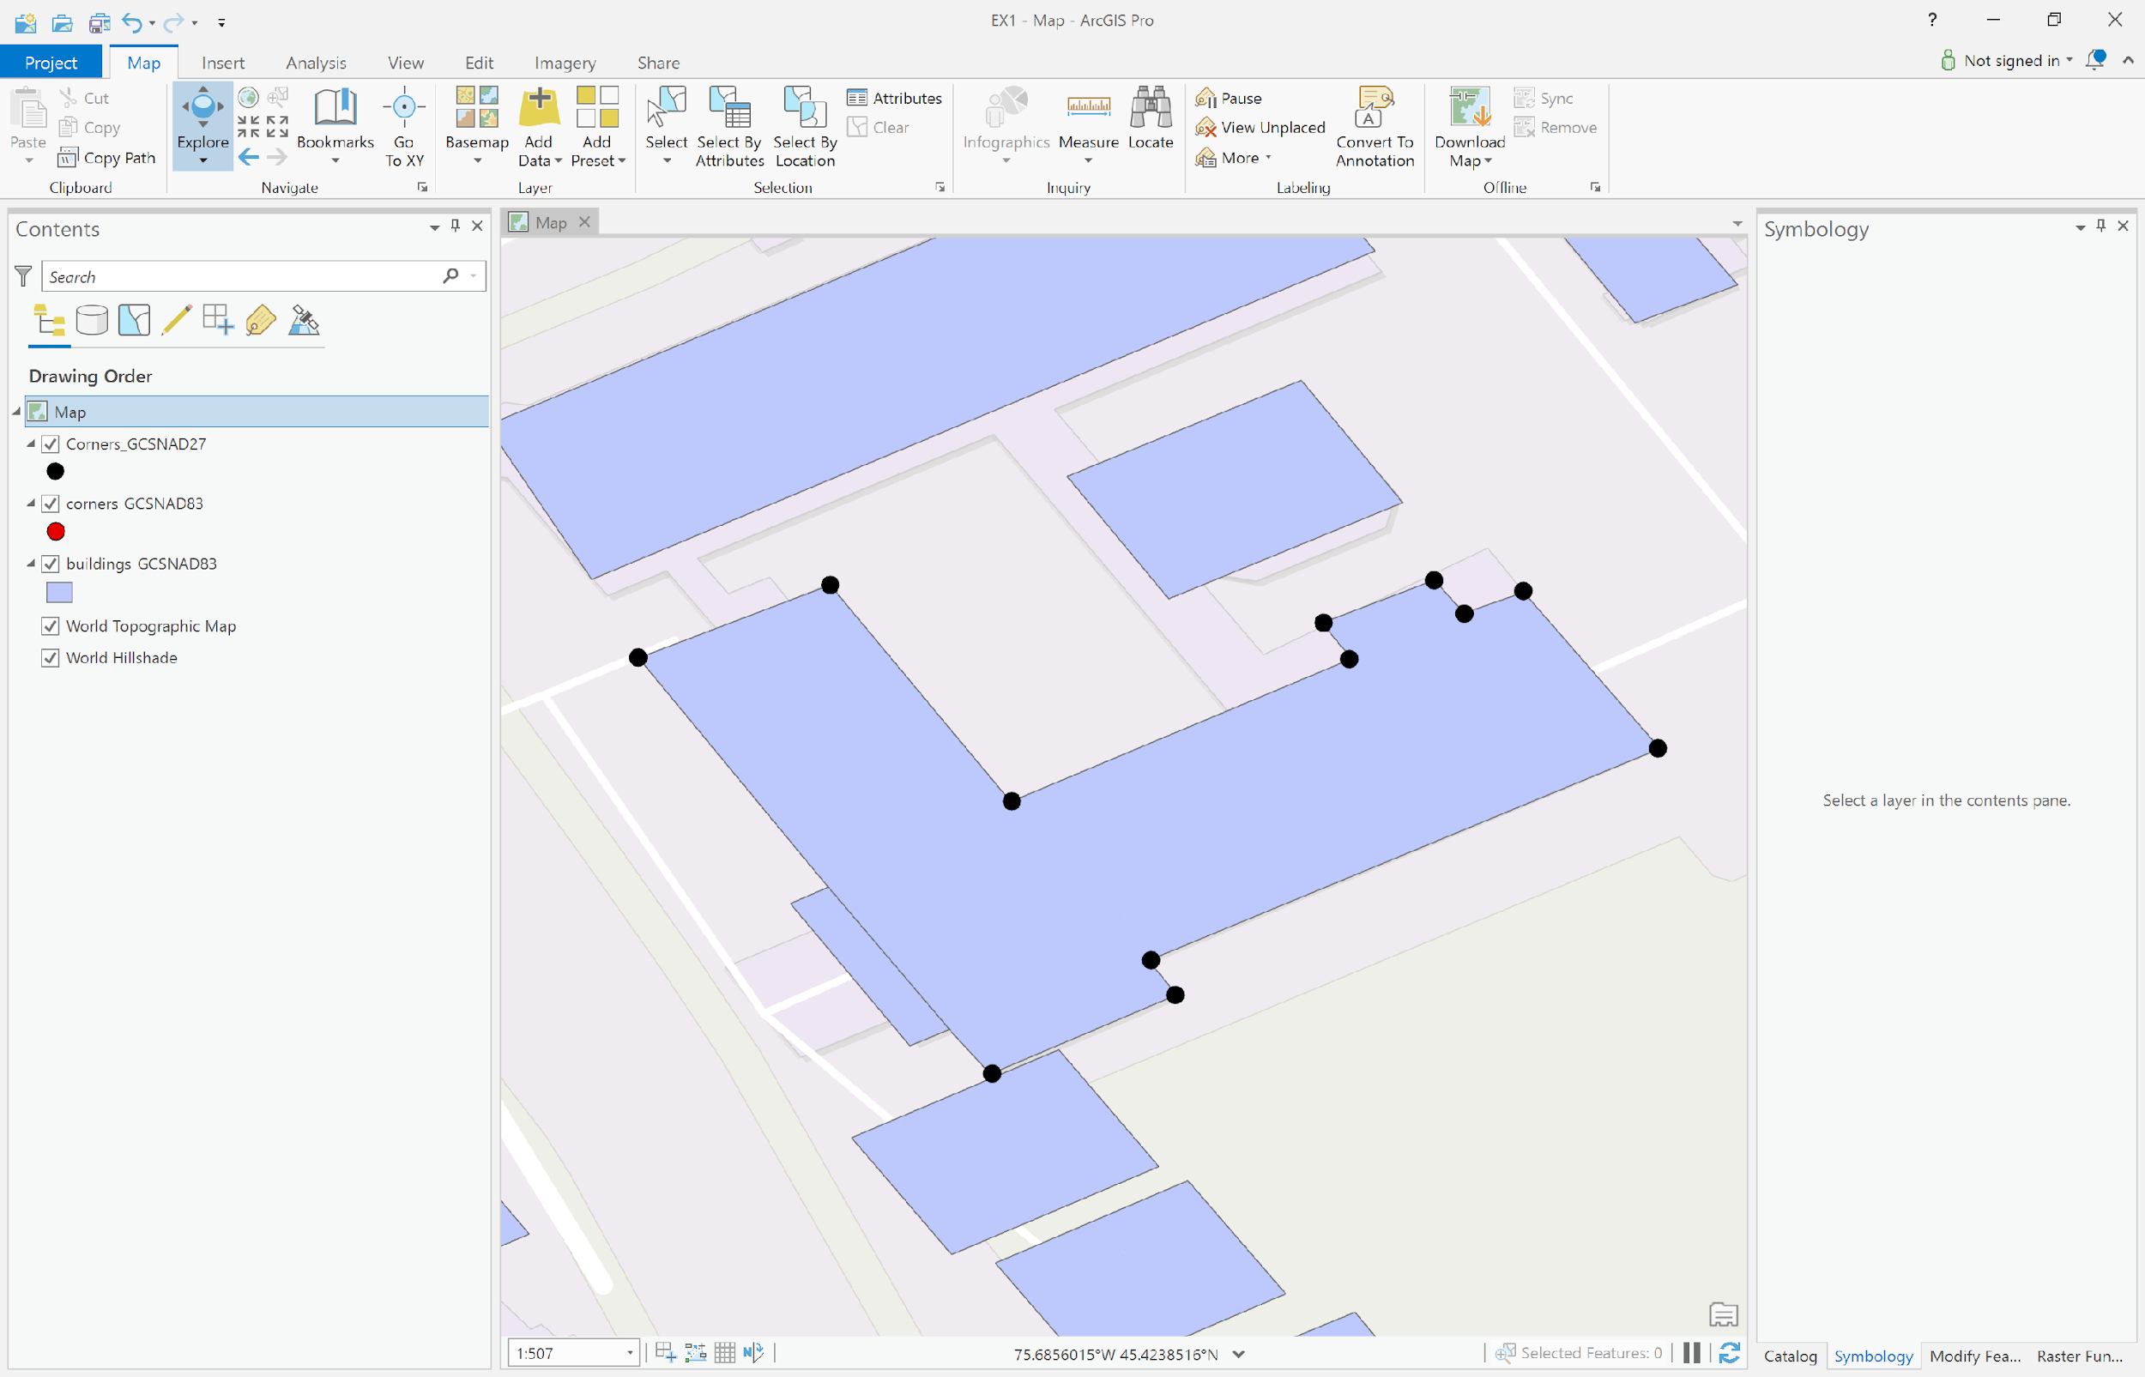

***Q10: How do I get coordinates of both NAD27 and NAD83 for each point in a set of points?***

To acquire coordinates for a set of points in a predefined coordinate system, there are three methods:

1. Use the identify tool and click on a point and examine the coordinates.
2. Use the ‘Add XY Coordinates’ tool in Data Management Tools -> Features (the easiest).
3. Use the Add Field Tool in the Geoprocessing Fields toolbox and then calculate geometry in those fields in the native coordinate system of the layer(s).

The second and third approaches allow you to acquire coordinates for more than one point at a time with high precision, so you will likely use either of those most of the time. To build additional GIS skills, this example will use the third method, which takes a bit longer but uses more tools that are useful in other contexts.

1. Create a new Map.
2. Add the Corners_GCSNAD27 layer to ArcGIS Pro. Click OK to any dialog that comes up. We are not concerned with alignment here but rather with adding coordinates in the native coordinate system, so it doesn’t matter what transformation we choose.
3. Go to Data Management Tools -> Fields and right-click on the Add Field tool and choose Batch

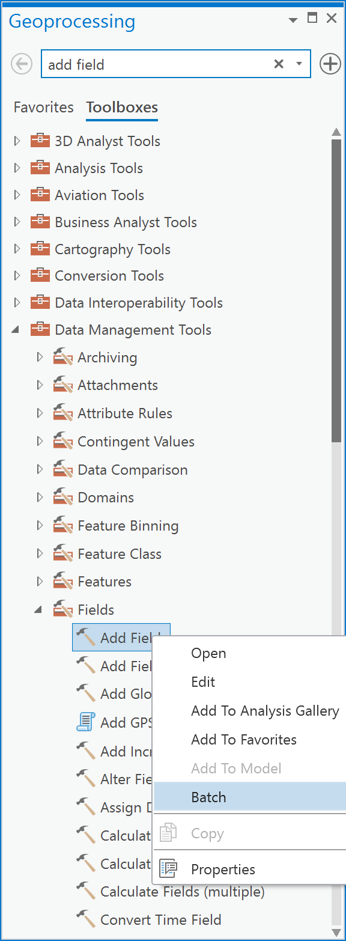

1. You will now see the batch processing dialog. In the ‘Choose a batch parameter’ dropdown choose ‘Field Name’ and click Next:

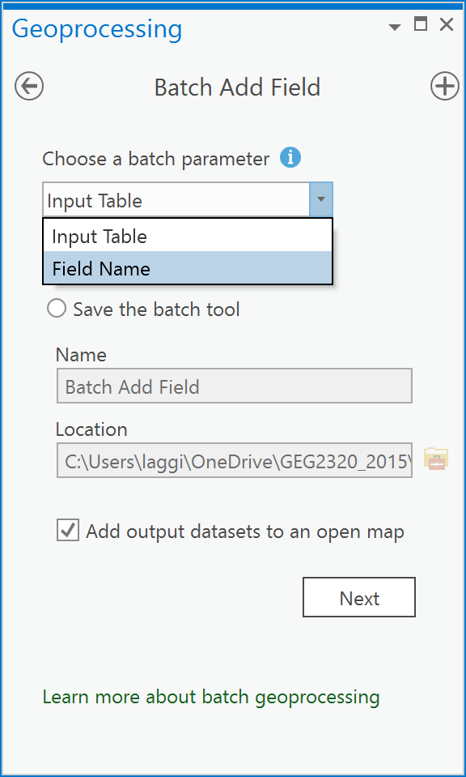

1. Now you will see Parameters dialog. In this dialog choose ‘Corners_GCSNAD27’ from the dropdown under ‘Input table’. Under ‘Batch Field Name’ type in LON27 and LAT27 as you see below. Finally, under ‘Field type’ choose ‘Double’ and click Run:

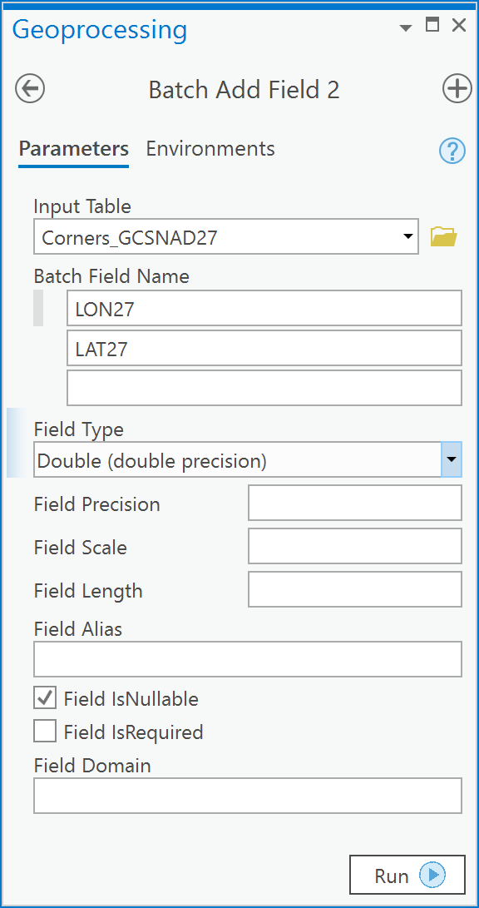

1. Now, right click on the ‘Corners_GCSNAD27’ layer and choose Attribute Table. You will see that there are now two new attributes, one called LON27 and one called LAT27.

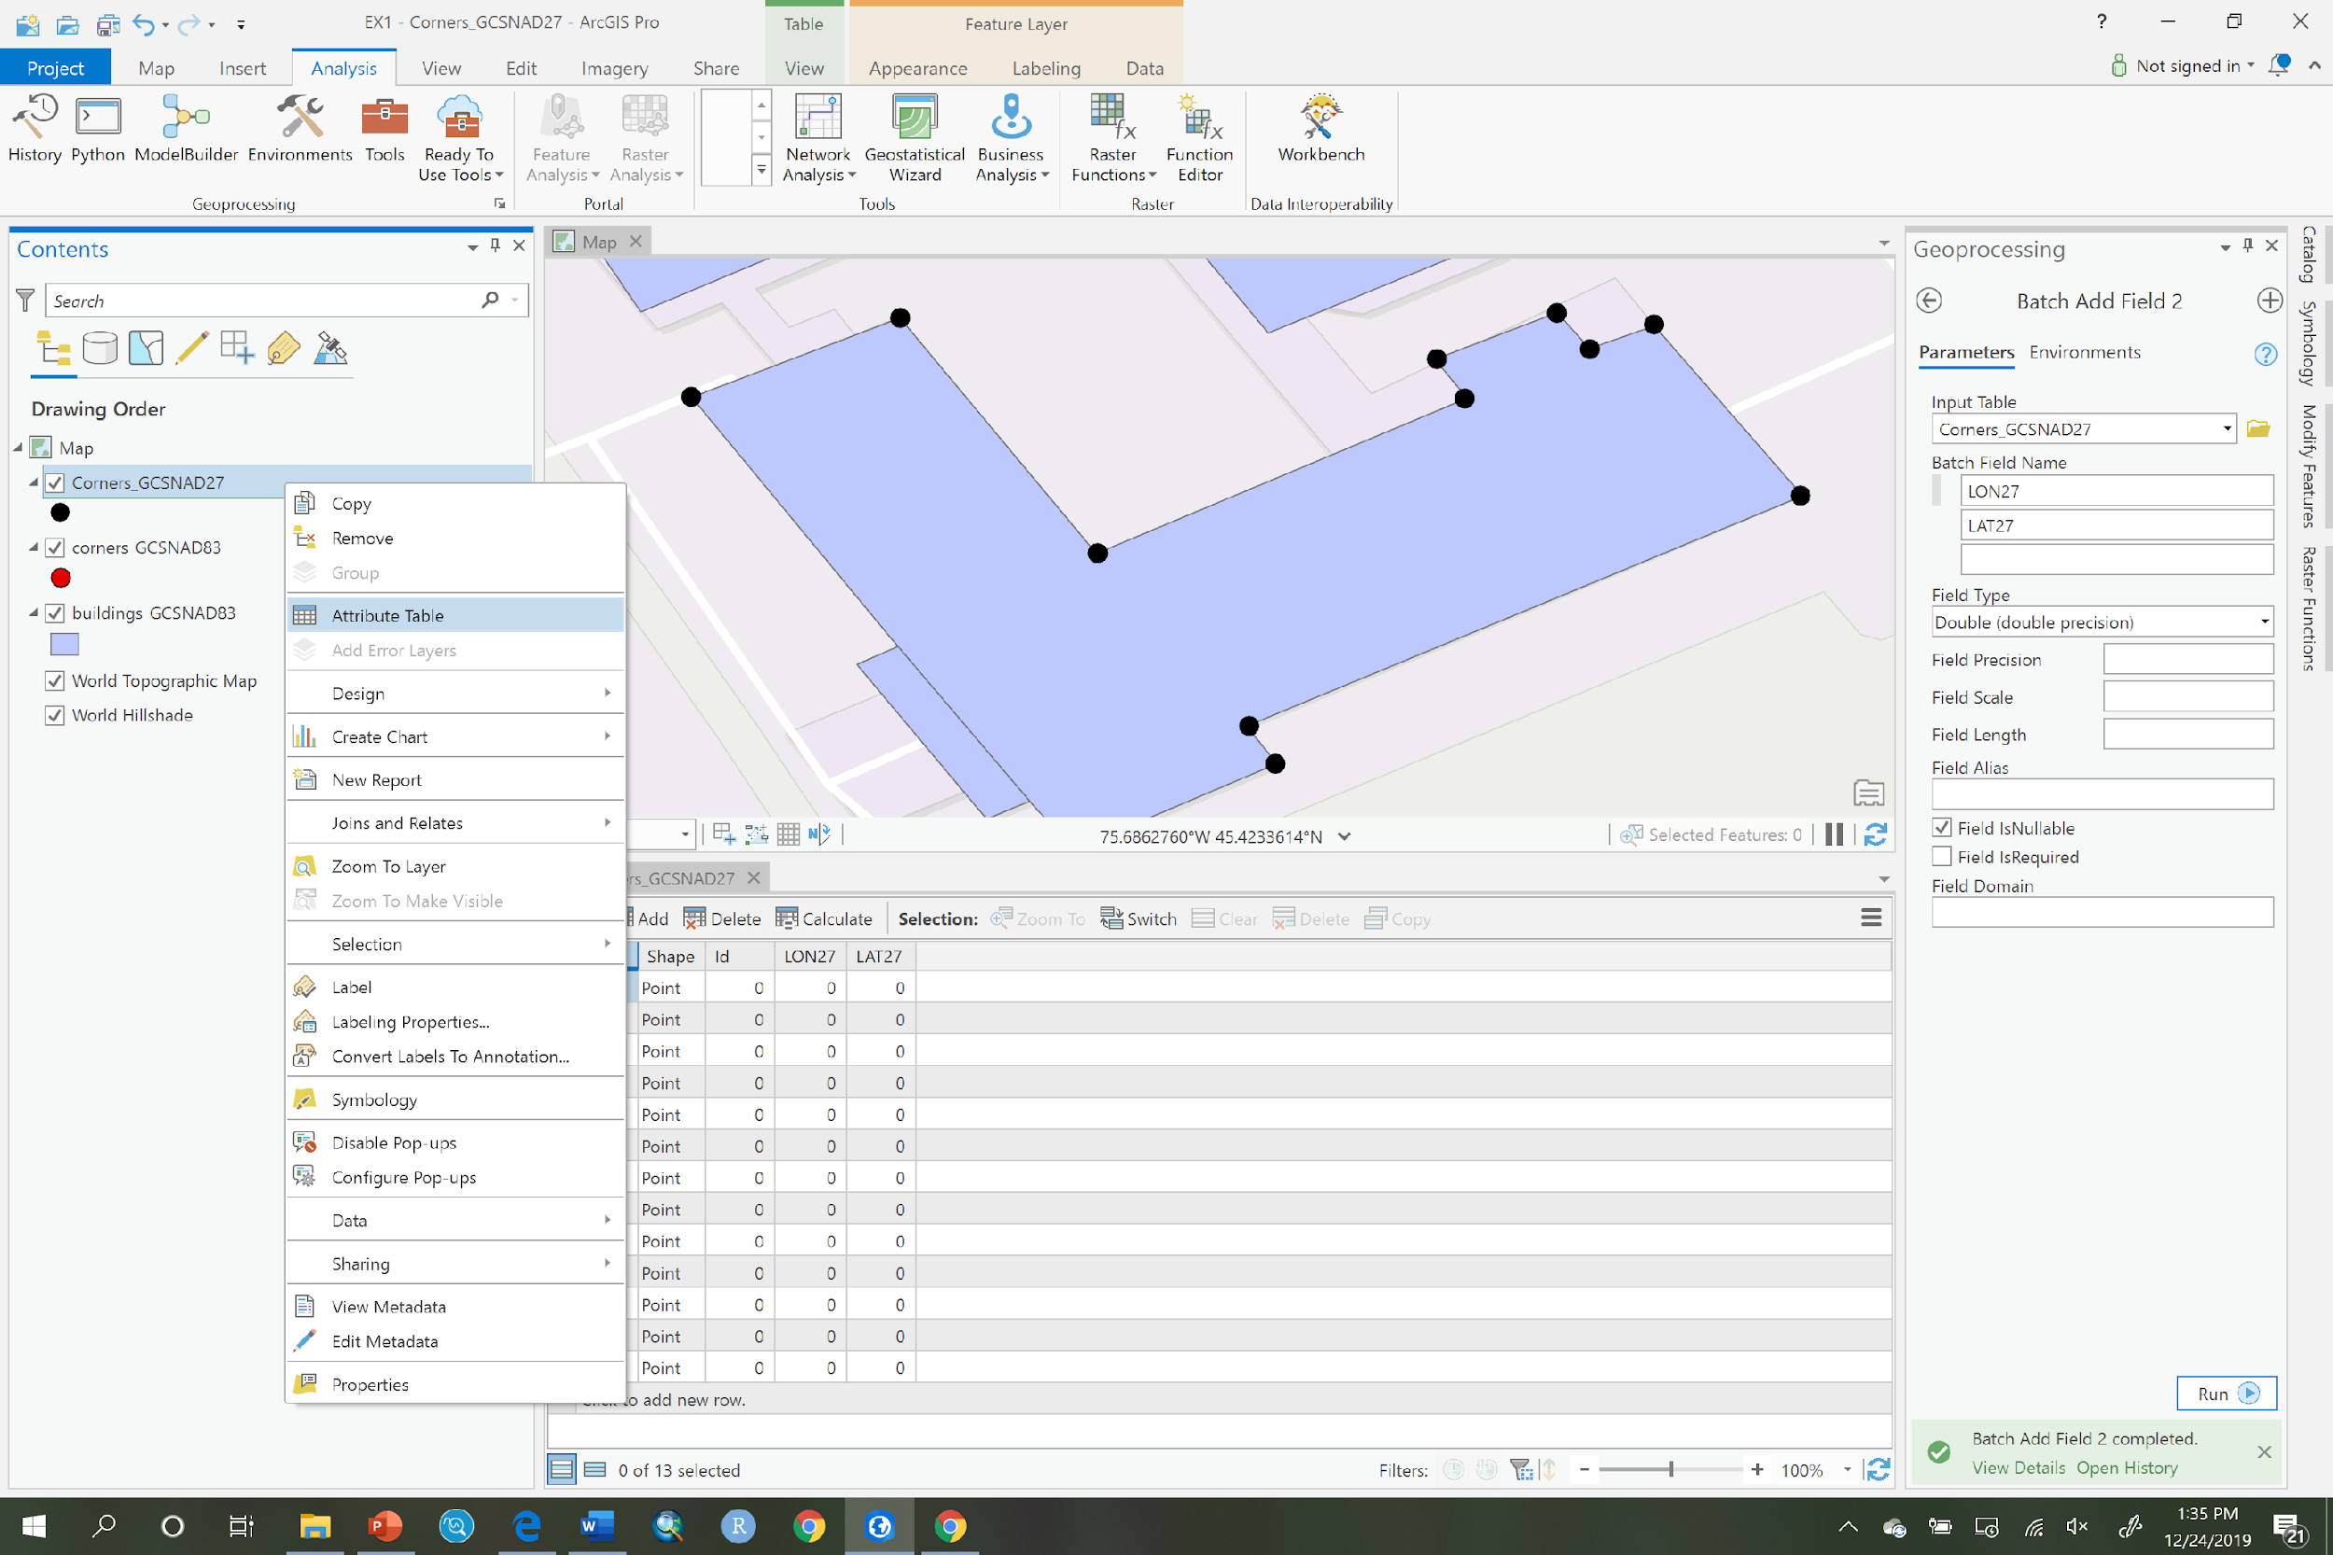

1. Right click on the LON27 attribute and choose ‘Calculate geometry’:

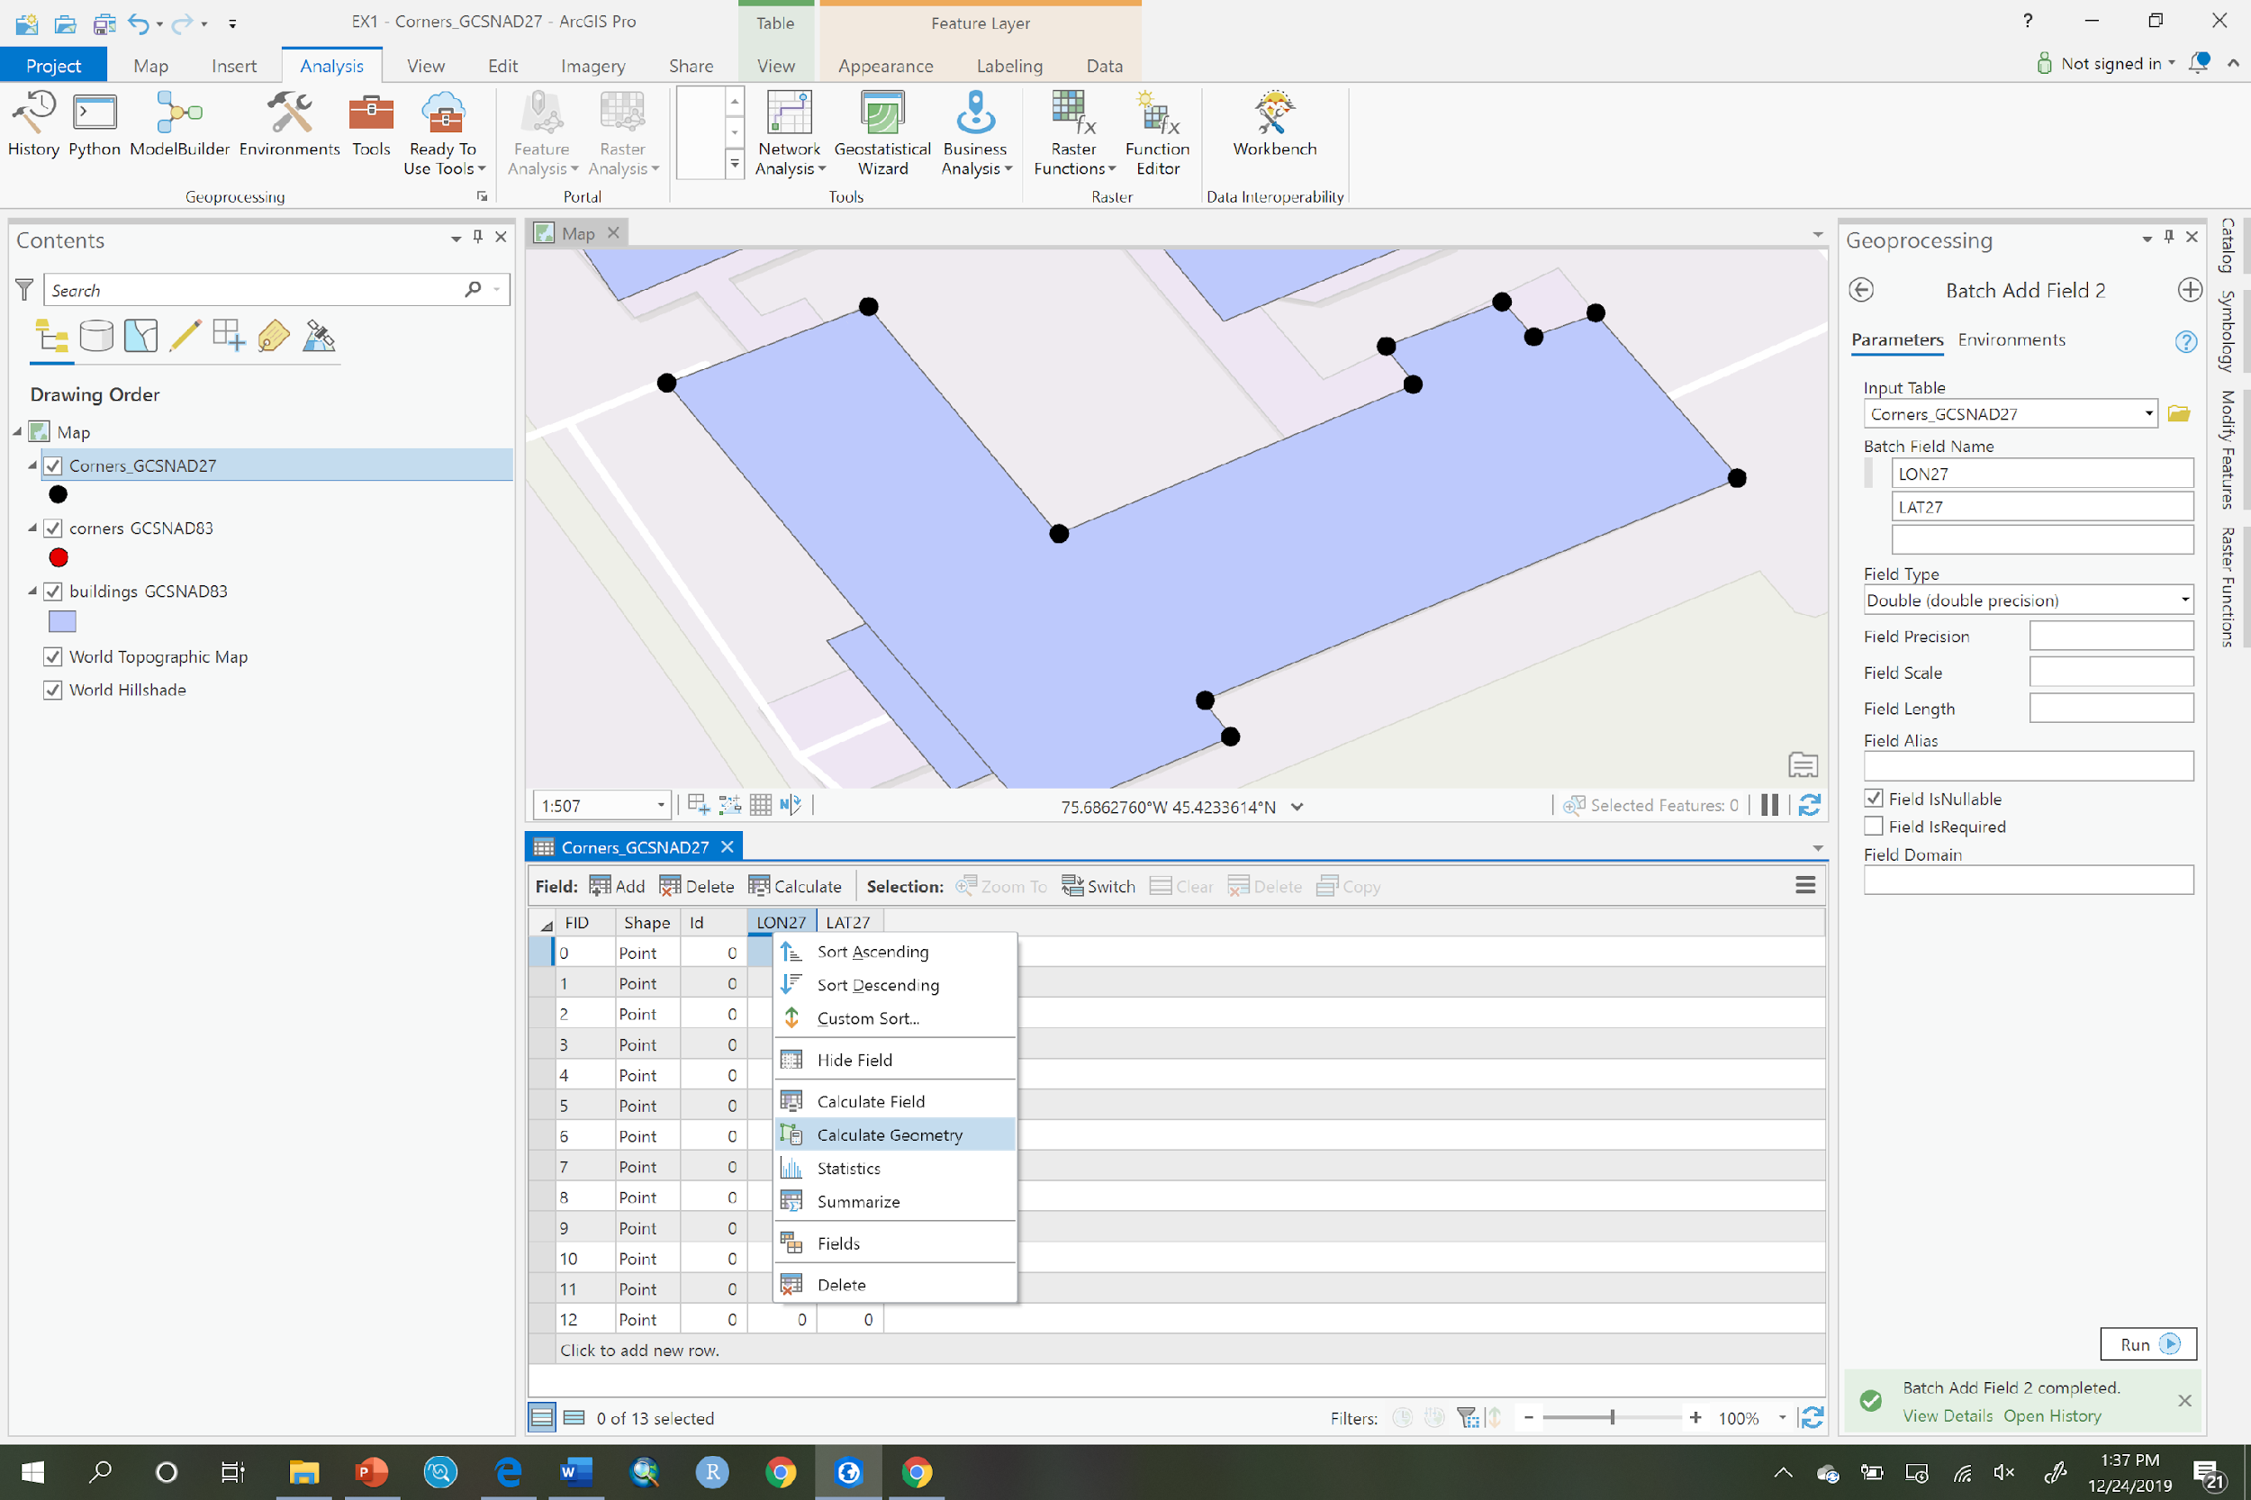

1. Under Geometry Property-Target Field, choose LON27 and then LAT27. Beside LON27 in the Property dropdown, choose Point x-coordinate and beside LAT27 choose Point y-coordinate. Under the Coordinate System, choose ‘Corners_GCSNAD27’ and the coordinate system will then specify GCS_North_American_1927 as the coordinate system to calculate the GCS values within. Your dialog should look like the example below, if so, click Run:

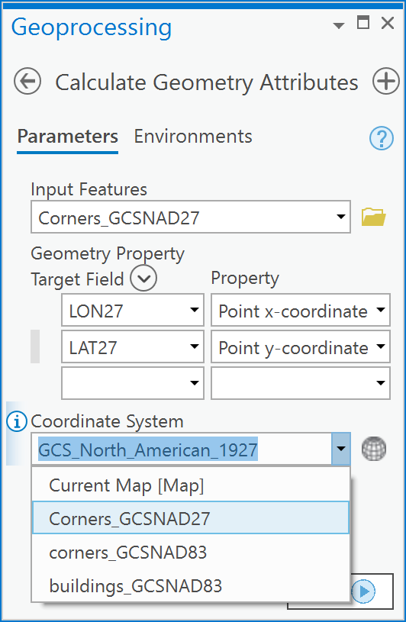

1. You should now see the following in your Attributes pane:

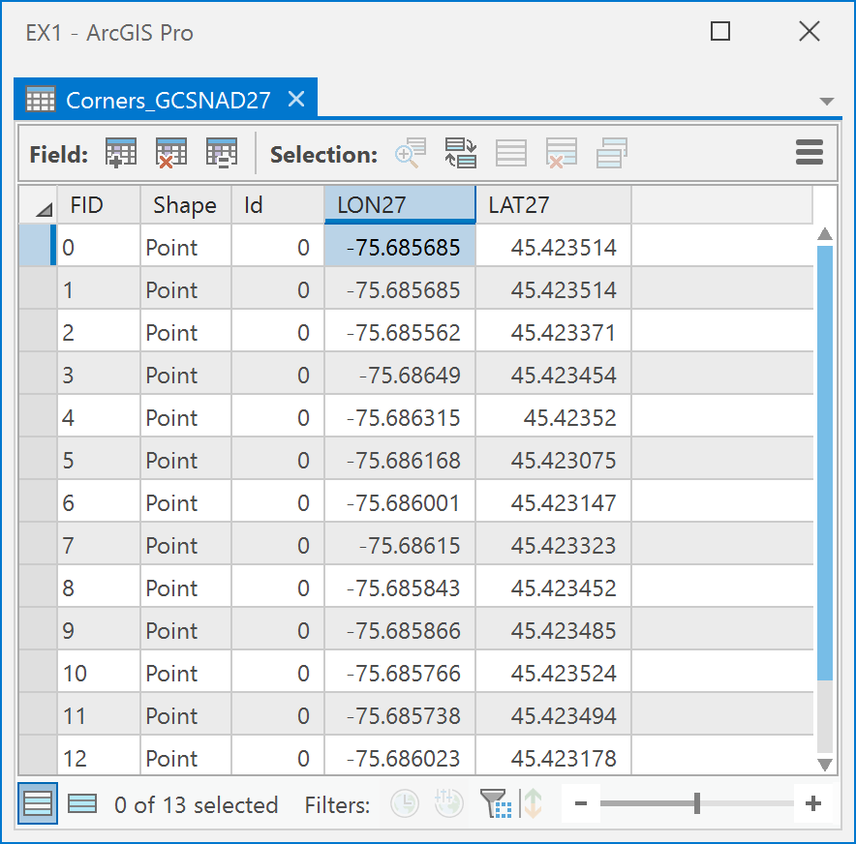

1. You have now calculated the coordinates of each building corner in NAD 27 Longitude and Latitude.
2. Now change the display map coordinate system to NAD 83 by right clicking on the Map in the Table of Contents and choosing Properties. In the Properties dialog choose the Coordinate System item. Then choose Geographic Coordinate System -> North America -> Canada -> NAD 1983:

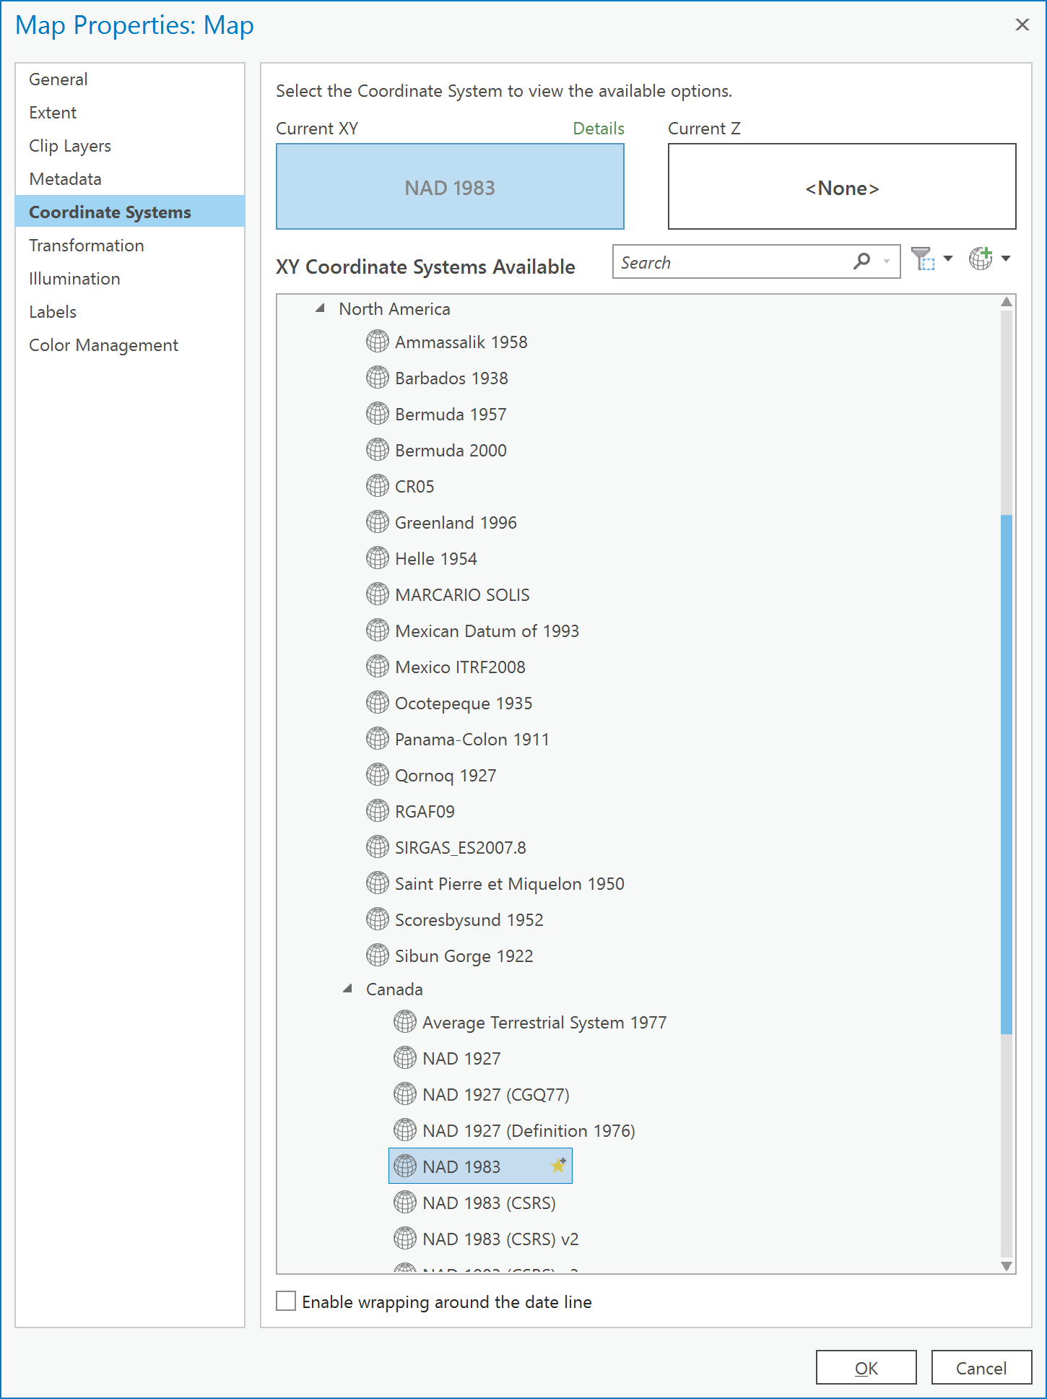

1. Now switch to the Transformation item and choose ‘NAD 1927 to NAD 1983 NTv2 Canada’ and click OK.

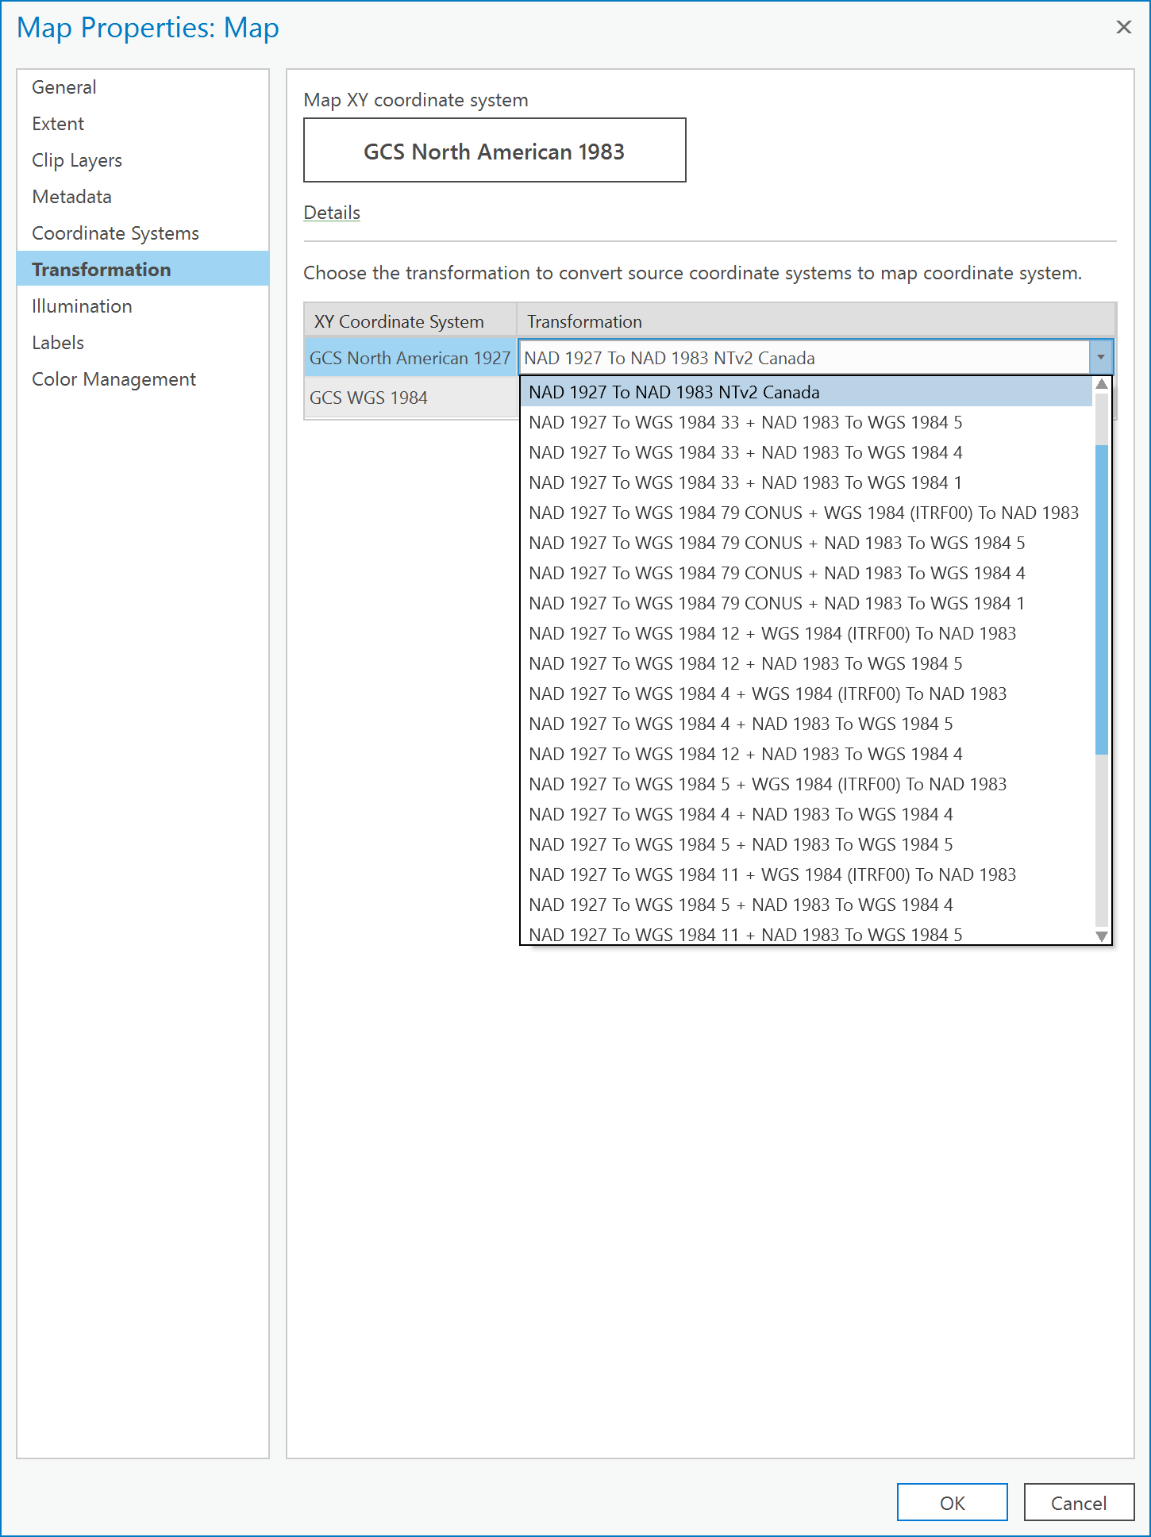

1. Next, repeat steps 3 and 4. You will see the Parameters dialog. In this dialog choose ‘Corners_GCSNAD27’ from the dropdown under ‘Input table’. Under ‘Batch Field Name’ type in LON83 and LAT83 as you see below. Finally, under ‘Field type’ choose ‘Double’ and click Run:

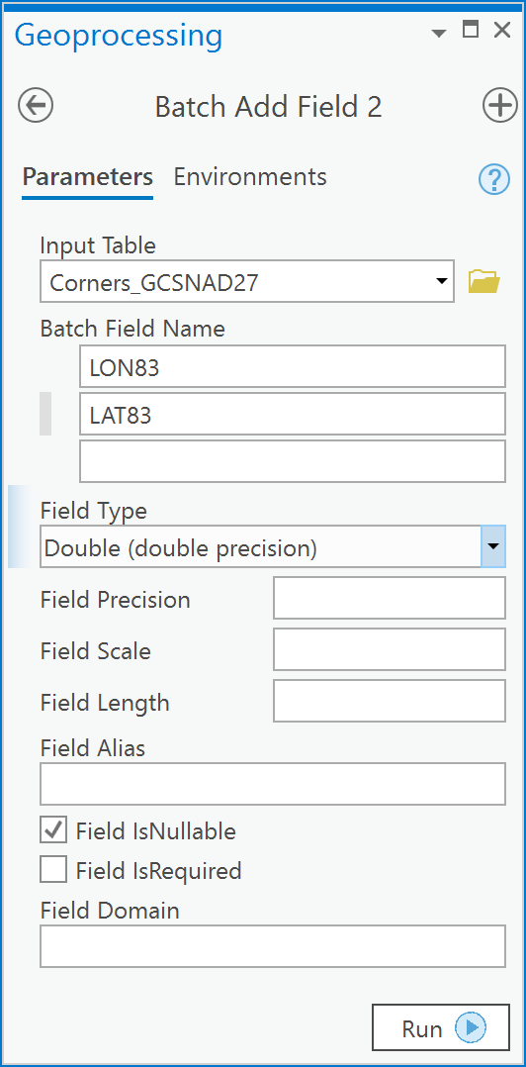

1. Next, in the Attributes pane, right click on the LON83 field and choose ‘Calculate Geometry’:

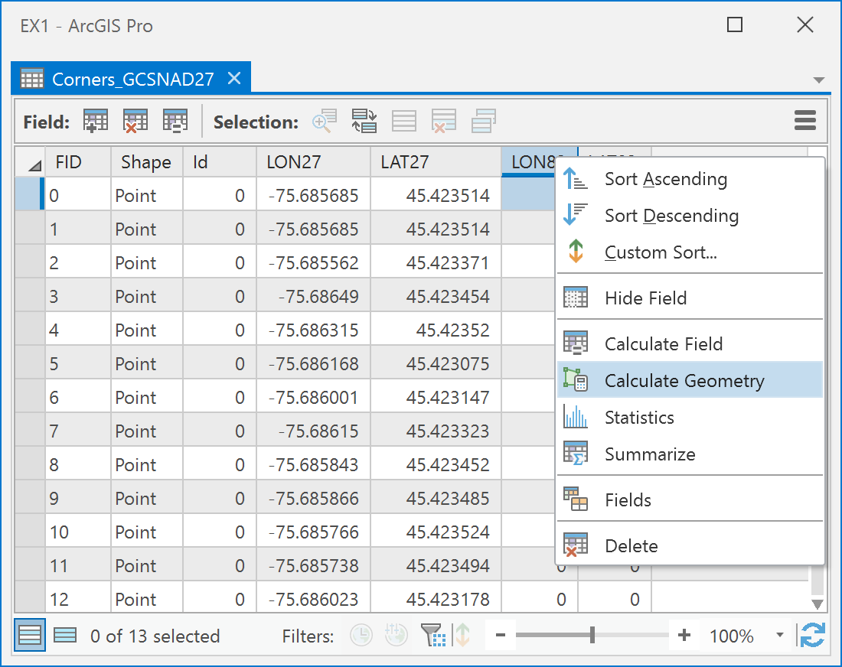

1. In the Calculate Geometry Attributes dialog, fill in the following parameters to calculate the coordinates in NAD83. Click Run once your dialog looks like the one below:

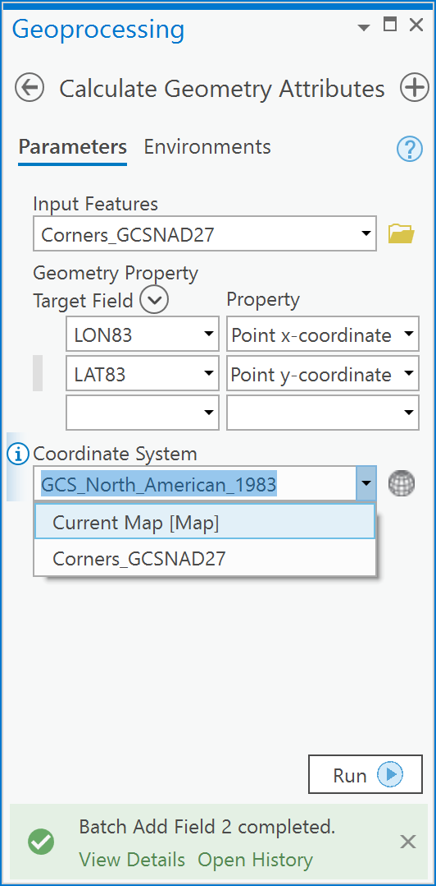

1. Now you will see that the NAD27 coordinates and NAD83 coordinates differ in the 3-5th decimal places:

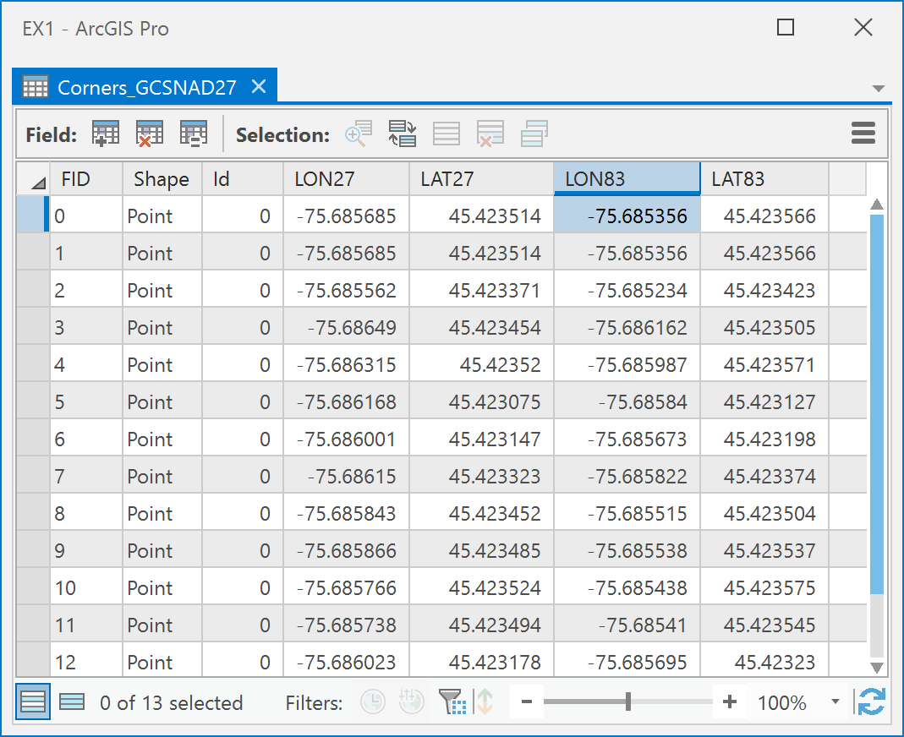

***Q11: How do I make a permanent change into NAD83 (or any coordinate system) for a digital geospatial layer?***

As noted earlier, a display transformation is not a permanent change of the coordinates stored within a file. To permanently change coordinates there are two methods:

1. Export the current layer from the TOC using the ‘Feature Class to Feature Class’ Geoprocessing tool (also under Conversion Tools -> To Geodatabase) and specify the geographic transformation within the Environment settings of the Feature Class to Feature Class tool.
2. Use the Toolbox tool called ‘Project’ under Data Management -> Projections and Transformations. This method is often preferred because it is made specifically to change coordinate systems of vector spatial data.
3. In the Geoprocessing pane, open the Data Management Tools -> Projections and Transformations -> Project tool:

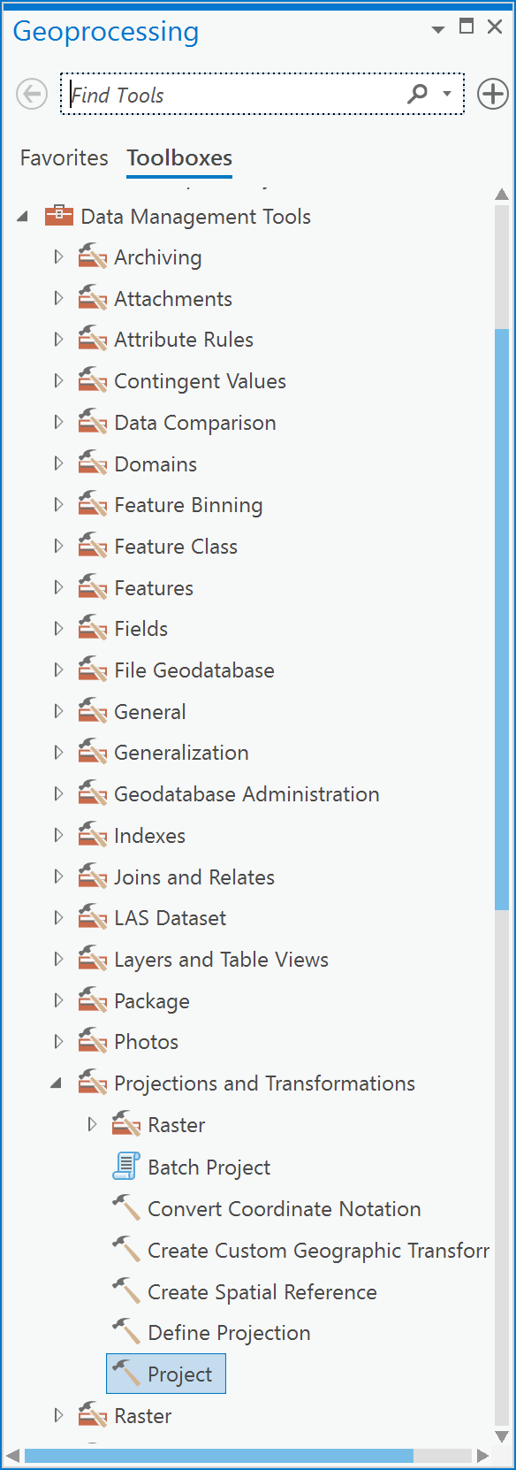

1. In the Project tool dialog, under Input Dataset of Feature Class, choose the ‘Corners_GCSNAD27’ layer. Under Output Dataset or Feature Class, name your output ‘NewCornersNAD83’. Under output Coordinate System, choose GCS_North_American_1983. Finally, under Geographic Transformation, choose ‘NAD 1927 to NAD 1983 NTv2 Canada’ and click Run:

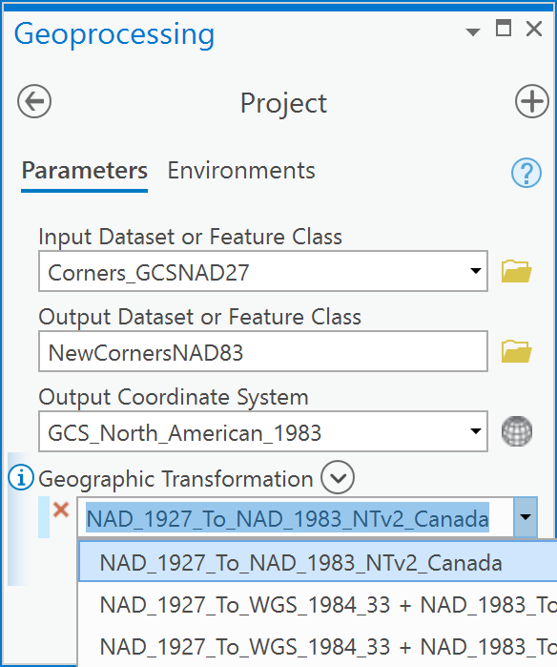

1. Now, we will see if everything worked as expected. Create a new Map. Add the ‘Buildings_GCSNAD83’, ‘Corners_GCSNAD83’ and the ‘NewCornersNAD83’ to the map. They should all align without specifying a transformation:

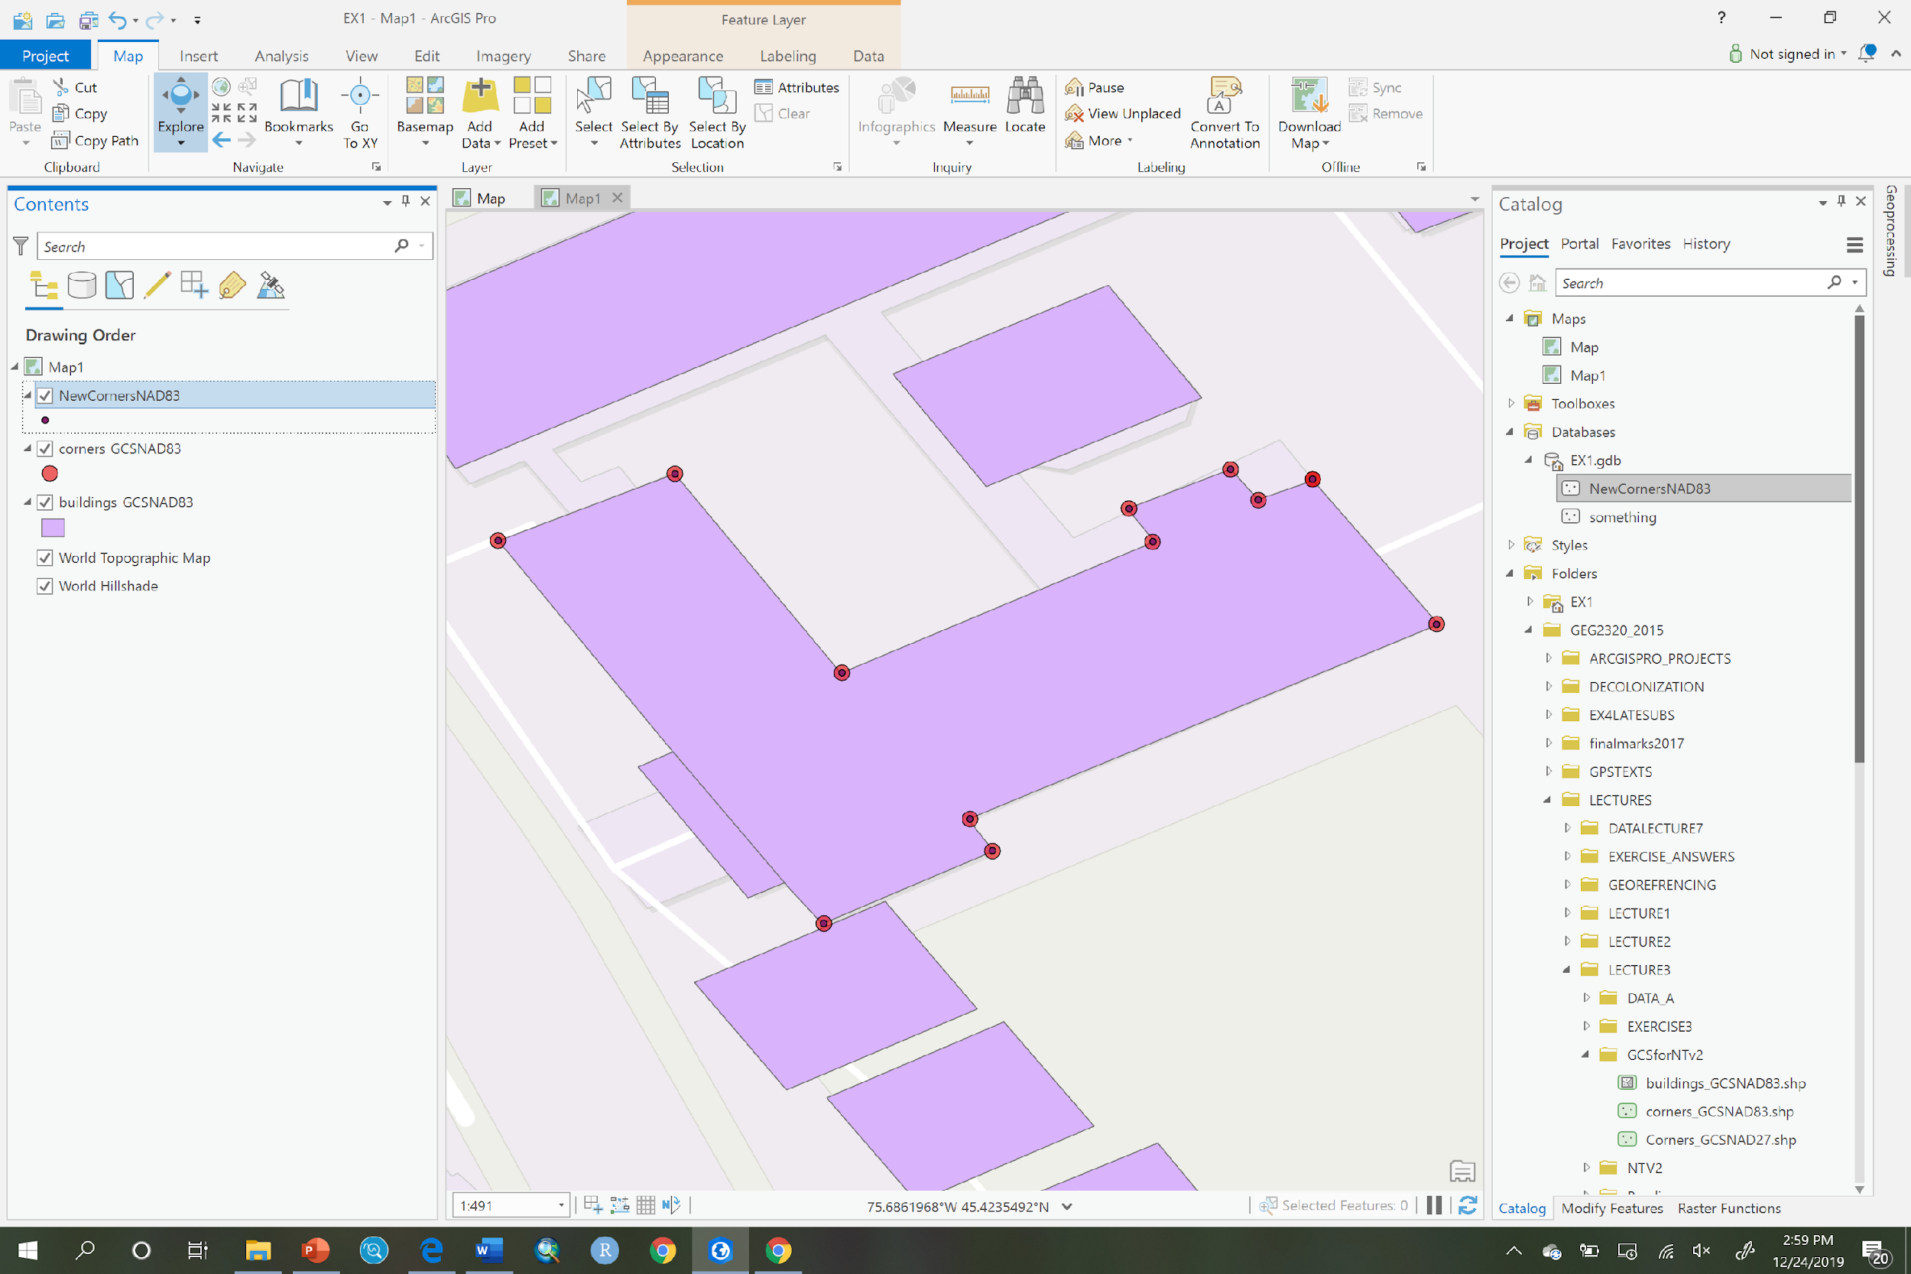

Answer the following questions.

1. [2 point] Provide the real-world distance of 1 degree of longitude at the following latitudes assuming a sphere as the model for the earth (see Q3 and Q4):

|  |  |
| --- | --- |
| *Latitude* | *Distance (km)* |
| 5 |  |
| 40 |  |
| 56 |  |
| 65 |  |
| 90 |  |

What do you notice about the real-world distance of 1 degree of longitude, as latitude decreases towards the equator? Why?

1. [2 points] Calculate the decimal degree equivalents of the following coordinates to 5 decimal places (see Q2).

|  |  |  |  |  |
| --- | --- | --- | --- | --- |
| *Latitude* | *Longitude* | *Latitude dd* |  | *Longitude dd* |
| 45°6'37'' N | 75°40'12'' W |  |  |  |
| 45°12'12'' N | 75°54'46'' W |  |  |  |
| 45°15'15'' N | 75°26'2'' W |  |  |  |
| 45°19'27'' N | 76°2'52'' W |  |  |  |
| 45°17'34'' N | 75°54'22'' W |  |  |  |
| 45°18'30'' N | 75°35'6'' W |  |  |  |
| 45°14'44'' N | 75°53'60'' W |  |  |  |
| 45°20'31'' N | 76°2'51' W |  |  |  |
| 45°20'33'' N | 75°43'25'' W |  |  |  |
| 45°21'2'' N | 75°45'53'' W |  |  |  |
| 45°21'11'' N | 75°21'10'' W |  |  |  |
| 45°25'42'' N | 75°47'23'' W |  |  |  |
| 45°22'14'' N | 75°51'25'' W |  |  |  |
| 45°25'25'' N | 75°57'20'' W |  |  |  |
| 45°23'0'' N | 76°51'39'' W |  |  |  |
| 45°55'55'' N | 75°54'28'' W |  |  |  |
| 45°25'54'' N | 75°39'41'' W |  |  |  |
| 45°18'1'' N | 75°29'26'' W |  |  |  |
| 45°21'19'' N | 75°32'58'' W |  |  |  |
| 45°29'1'' N | 76°46'4'' W |  |  |  |

1. [2 points] Calculate the *base scale* location uncertainty for the following map scales (see Q5):

|  |  |
| --- | --- |
| *Scale* | *uncertainty (m)* |
| 1 :500 |  |
| 1 :20000 |  |
| 1 :50000 |  |
| 1 :300000 |  |
| 1 :4000000 |  |

1. [2 point] Why does uncertainty increase with decreasing map scale?
2. [2 points] Calculate the location uncertainty for the following vector *digital* geospatial layers that were digitized from maps at the base scales listed (see Q5),

|  |  |
| --- | --- |
| *Base scale* | *uncertainty (m)* |
| 1 :5000 |  |
| 1 :20000 |  |
| 1 :50000 |  |
| 1 :300000 |  |
| 1 :4000000 |  |

1. [3 points] Calculate the uncertainty in location for the following raster layers (*all of which have square cells and were encoded from digital geospatial vector layers*), given the information provided in the table (see Q6):

|  |  |  |
| --- | --- | --- |
| *Base scale* | *Raster resolution in m (one side of a cell)* | *Uncertainty (m)* |
| 1 :1000 | 0.50 |  |
| 1 :25000 | 4 |  |
| 1 :63360 | 30 |  |
| 1 :250000 | 60 |  |
| 1 :5000000 | 2000 |  |

1. [5 points] You are provided with a layer called mine_entrances.shp in lab2.zip. This data represents the locations of mine entrances in the North American Datum of 1927 (NAD27) (you must define that coordinate system using the define projection tool so that ArcGIS recognizes that it as NAD27). Create a table that shows the longitude and latitude of each point (mine entrance) in both NAD27 and NAD83. Include a fifth column in which you calculate the real-world distance (in meters) between the NAD27 and NAD83 coordinates. Examine the table you have created and explain what you observe and why. **Hint**: You may want to sort your table using columns of interest in order to uncover a pattern.

|  |  |  |  |  |  |
| --- | --- | --- | --- | --- | --- |
|  | NAD27 | | NAD83 | |  |
| *MineID* | *Longitude* | *Latitude* | *Longitude* | *Latitude* | *Distance* |
|  |  |  |  |  |  |
|  |  |  |  |  |  |
|  |  |  |  |  |  |
|  |  |  |  |  |  |
|  |  |  |  |  |  |
|  |  |  |  |  |  |
|  |  |  |  |  |  |
|  |  |  |  |  |  |

1. [5 points] Read the following blog posts by Sarah Sibbett:

* <https://resources.esri.ca/getting-technical/your-guide-to-canadian-datum-transformations-and-arcgis-online-part-1>
* <https://resources.esri.ca/getting-technical/your-guide-to-canadian-datum-transformations-and-arcgis-online-part-2>
* <https://resources.esri.ca/getting-technical/your-guide-to-canadian-datum-transformations-and-arcgis-online-part-3>
  + What coordinate systems are most Canadian data within?
  + What is the default coordinate system for ArcGIS Pro?
  + What transformation is required to convert coordinates from NAD83 CSRS to WGS84 in Canada?
  + What transformation is required to convert coordinates from NAD83 Original to NAD83 CSRS in Ontario?
  + In Ottawa (see figure on the next page), what are the differences in meters between:
    - NAD27 and NAD83 (original).
    - NAD83 (original) and NAD83 CSRS.
    - NAD83 CSRS and WGS84.

**Notes**: You can find Ontario NTv2 transformation files here: <https://www.arcgis.com/home/item.html?id=7d26e16ba42040d7a4ae66a4e02d16a0>. Such files would be necessary when working with municipalities that have not adopted NAD83 or WGS84 coordinate systems. To download province-specific files to transform between NAD83 and NAD83 CSRS see <https://webapp.geod.nrcan.gc.ca/geod/data-donnees/transformations.php> - you would need to create an account and sign in to download them. You might want to know about the 2022 change in the US for data there and can read it here: <https://geospatial.blogs.com/geospatial/2018/08/new-2022-state-plane-coordinate-system-will-change-locations-by-up-to-15-meters.html>

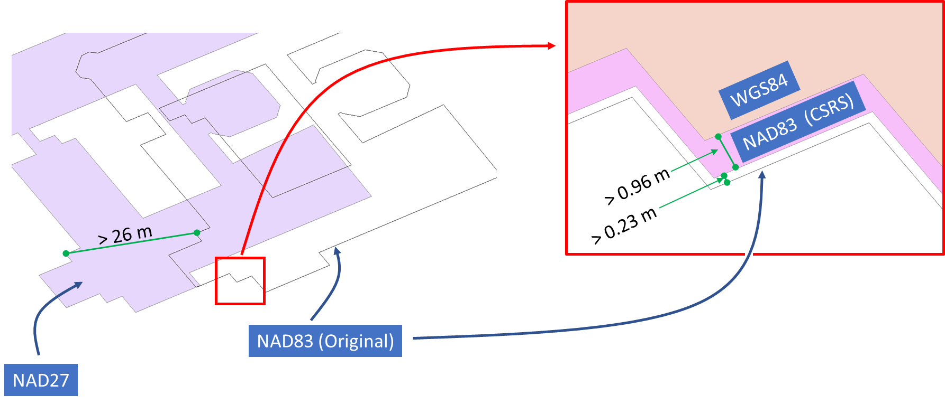

1. [4 points] Create a Map (e.g., a layout) in the coordinate system of NAD 1983 Modified Transverse Mercator Zone 9. None of the layers you will use have a pre-defined coordinate system/projection. Your map should contain the following layers that you can find in lab2.zip:

|  |  |
| --- | --- |
| Layer | Coordinate System MeTADATA |
| buildings_1_NAD83.shp | North American Datum of 1983 |
| buildings_2_NAD27.shp | North American Datum of 1927 |
| buildings_3_NAD27_UTM18N.shp | Universal Transverse Mercator Zone 18 N based on NAD27 geographic coordinates |
| buildings_4_NAD83_CANADA_ALBERS.shp | Canada Albers Equal Area Conic based on NAD83 geographic coordinates |